
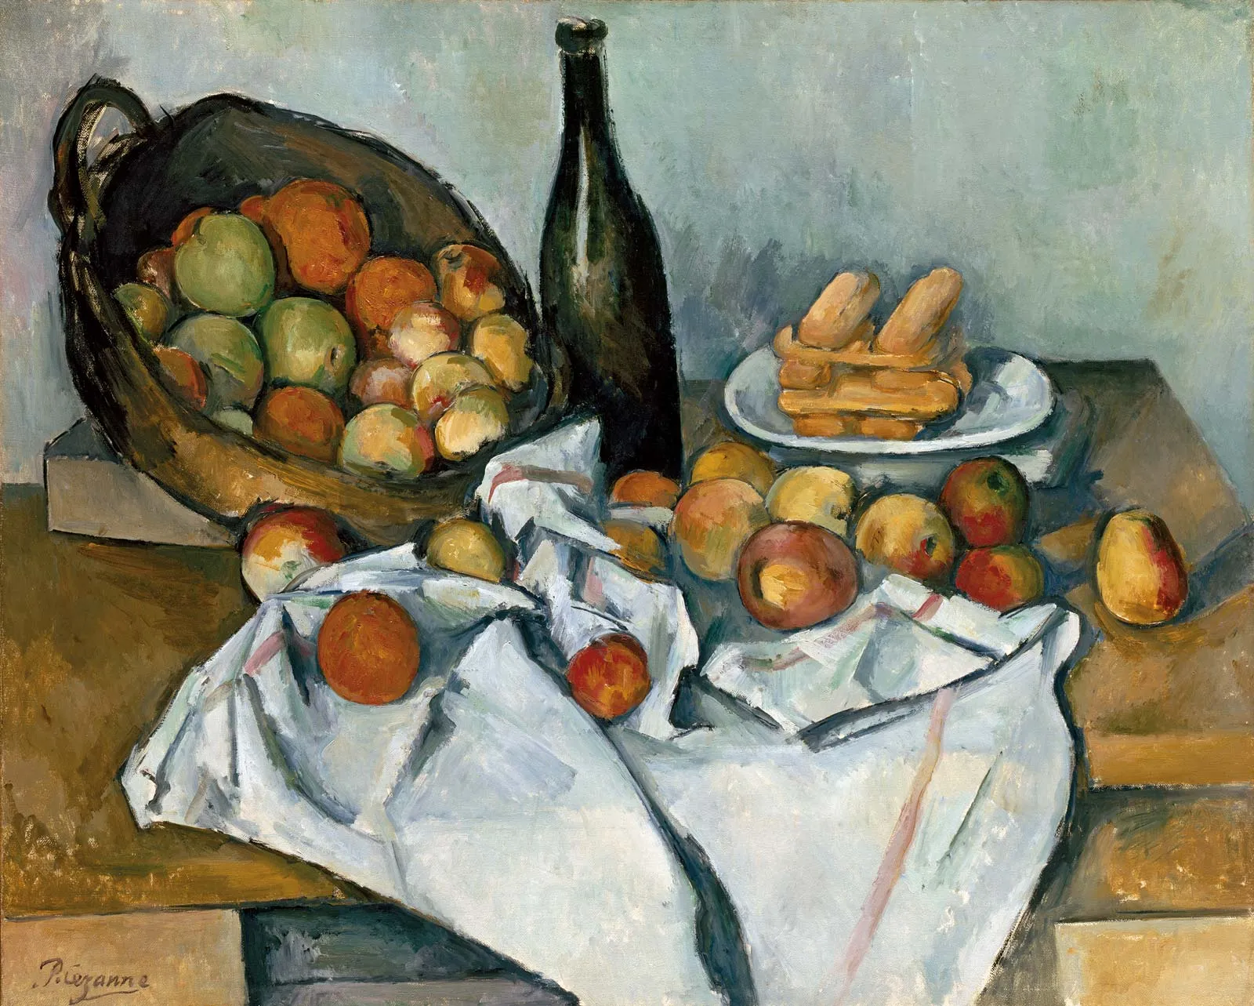

Welcome to Year 5

Dear Parents and Carers,
I hope that you and your family have enjoyed the summer break. We’ve already made an excellent start to the year with the class and I would like to share some of our curriculum highlights and key information with you.
If you have any questions, please don’t hesitate to get in touch,
Miss Thomas

 | Y5 Autumn | Homework Formal homework will be set on Fridays and should be submitted by the following Thursday. This homework will link to a variety of subject areas and will either act as consolidation of work covered that week, or as a pre-learning task for the following week. If applicable, the mark scheme for the homework will be sent home. This is so you and your child can get immediate feedback on how well they have completed the task. Homework that is returned on time is rewarded with 1 dojo point, if it is marked, your child will receive an additional dojo point.  Reading Children should read for at least 15-20 minutes 3 times a week at home. Please sign their Reading Journal when they read to you (at once twice a week). A bookmark has been sent home with some question starters to help you engage with your child and their reading. If your child reads to themselves, they can record this in their Reading Journal themselves. Children should bring their reading book and journal into school each day. Children are encouraged to celebrate finishing a book they have read by updating our class display on how many books we have read collectively.  Mental Maths Children should log onto TTRockstars for a 10 minute session at least 3 times a week.  Spelling Each week we will focus on a specific spelling rule and children will be tested on words related to these rules at the end of the week. The spelling rules Year 5 cover are based on the Year 5/6 Spelling List. You may wish to visit these rules and lists at home to complement the work we are doing in school. A copy of the weekly lists and the 5/6 list have been posted on Class Dojo. Some children may be working on separate bespoke lists in addition to the whole class sessions.  PE and Swimming  PE sessions will be on Tuesdays and Thursdays - children should come to school IN their PE kit: a school jumper, a PE t-shirt, shorts and trainers. During the winter months jogging bottoms will be needed.  Swimming sessions will be on Fridays - children should come to school IN their PE kit and bring their swimming kit in a named bag.
Reading | Beowulf  The One and Only Ivan  Remembrance Day  Leonora Bolt Secret Inventor
Writing | Formal letter - invitation to Harvest Festival  Poetry - Harvest imagery  Instructions - How to prepare for a sleepover  Viking narrative - A Battle Scene  Persuasive writing - Family attraction leaflet  Poetry - personification
GAPS | Active and passive voice, Commas to clarify meaning,  Coordinating conjunctions, Possessive apostrophes, Inverted commas, Fronted adverbials, Relative clauses, Tense consistency, Modal verbs
Maths | Place Value  Addition and Subtraction  Multiplication and Division  Fractions
Science | Properties of Materials  Plastic Pollution  Reversible + Irreversible Changes  Global Warming
Computing | Online Safety  Systems and Searching  Video Production
History | The Anglo-Saxons and the Vikings
Geography | Marvellous Maps
Music | What shall we do with the drunken sailor?  Balinese Gamelan  Composing in ternary
Art | Still Life Drawing using pencils and chalk pastels
DT | Sewing a bag
Spanish | All About Me  The Way I Look
P.E. | Football, Swimming, Gymnastics
PSHE | Keeping/Staying Safe - Peer Pressure  Keeping/Staying Healthy - Smoking  Being Responsible - Looking Out For Others
R.E. | What would Jesus do?  If God is everywhere, why go to a place of worship??

