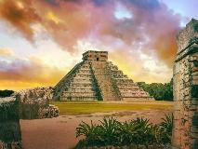
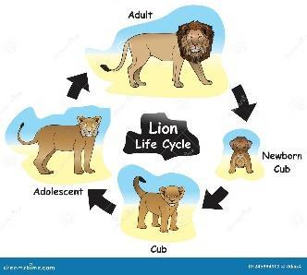

Y5 – Summer Term 2026

Dear Parents and Carers,
Here you will find important information about our curriculum in the Summer term. We have lots of wonderful things to look forward to, such as our class trip to a sculpture park and supporting Year 6 with the Summer production as their official ‘chorus line’. Thank you for your continued support with your child’s learning.
Miss Thomas
Homework
Weekly homework will be sent home on Fridays and is due back the following Thursday.
These activities will either consolidate previous learning, or act as preparation for upcoming learning across the curriculum.
Reading
Children should read for 15 minutes a day at least three times a week at home.
Times Tables Rock Stars
Children should complete at least 30 minutes on this each week.
 | PE  Our PE sessions will be on Mondays and Fridays.  
  Reading | Cogheart -Peter Bunzl  A Stone for Sasha -Aaron Becker  Oliver Twist - Charles Dickens  Kensuke’s Kingdom - Michael Morpurgo
  Writing | Non-chronological report – endangered animals  Focus on Shakespeare – A Midsummer Night’s Dream  Explanation text – life cycles on animals  Narrative story based on the Maya civilization
  Maths | Decimals  Negative Numbers  Converting Units  Measuring Volume
  Science | Animals, including Humans - to understand the changes as humans develop to old age.  Living things and their Habitats - life cycles; reproduction in plants and animals.
  Computing | Vector Drawing  Programming quizzes
  Geography | Central America – how the climate and landscape through time impacts on the people who live there
  History | Maya Civilization  Making comparisons between Britain and Central America in 900AD
  R.E. | Why do some people believe in God, and do some not?  How and why should religious communities do more to care about our Earth?
  Music | - Balise Music  - Composing in Ternary Form  - Singing for an audience (production)
  Art | Sculpture from recycled materials
  D.T. | Food and Nutrition – creating a Mexican feast
  Spanish | In the Classroom  Our past
  P.E. | Agility, Dance,  Rounders, Athletics
  PSHE | Inclusion and Acceptance  Puberty  Supporting our Mental Health

