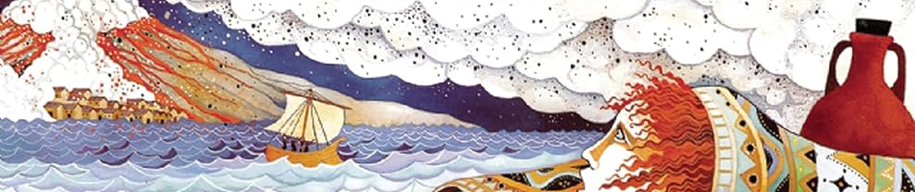
Year 4 Autumn Newsletter

Dear Parents and Carers,
Welcome back after the summer break - hopefully you all had an enjoyable and restful

holiday. The children have returned to school looking very smart and have settled well into the new routines of Year 4. Below you will find the key information for this term, we are very much looking forward to our year together. Mrs Maries and Miss Greenhalgh
Homework
Reading Children should read for 15-20 minutes a day, at least three times a week at home. Please initial their homework diary each week.
Maths Children will be assigned Mathletics activities throughout the week to complete at home. This is to reinforce classroom learning at home.
Children are expected to spend time on TT Rockstars to improve their times table recall.
Spelling Each week we will focus on a specific spelling rule and children will be tested on words related to these rules at the end of the week. You may wish to visit these at home to complement the work we are doing in school. A copy of the weekly lists can be found on Class Dojo.

 | Y4 Term 1
Reading | Whole class Reading – The Firework Maker’s Daughter, Curiosity - Story of a Mars Rover, Escape from Pompeii  Class Novels – Desirable
Writing | Narrative -Short stories, letters, diaries  Persuasive writing  Explanation Text  Kenning Poetry
Maths | Place Value  Addition and Subtraction  Measurement  Multiplication and Division
Science | Living things and their Habitats  States of Matter
Computing | The Internet - how computers connect to each other.  Creating media - audio production
Geography | Rivers and the Water Cycle
Art | Drawing  Full bodies in charcoal, pens and pencils scale and perspective, detailed observations  Banksy  Leonardo da Vinci
Spanish | My Town  Let’s Go
P.E. | Gymnastics  Rugby
PSHE | Keeping/Staying Safe - Cycle Safety  Keeping/Staying Healthy - Healthy Living  Being Responsible - Coming Home on Time
D&T | Textiles - Hanging Decorations
Music | Singing together and vocal skills.
R.E. | Believing -Why is Jesus inspiring some people?
PE
Please ensure your child has the correct PE uniform; a named Bolshaw t-shirt, shorts and trainers. During the winter months jogging bottoms and a warm top will be needed. Please ensure that all your child’s belongings are clearly labelled. Earrings must be removed on PE days.
PE will be on Wednesday and Thursday this term - children can come in their PE kits.
Swimming will start AFTER CHRISTMAS BREAK.
Children will take part in their Forest School session on Wednesday afternoons.. Information has been sent out separately by the office with regards to what the children are expected to wear.

