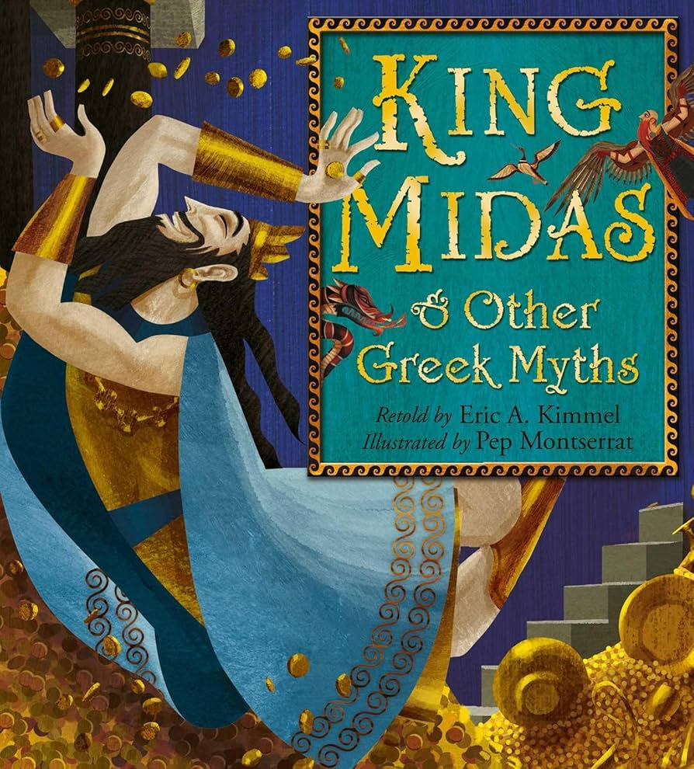
Year 4 Spring Newsletter

Dear Parents and Carers,
We hope you had a lovely winter break - hopefully you all had an enjoyable and restful

holiday and time to spend with family and friends. We will be looking at some very exciting topics this term and continuing our preparation for the Multiplication Check later this year. Below you will find the key information for this half term. Mrs Maries and Miss Greenhalgh

 | Y4
Reading | Whole Class Reading and Class Novels – Bill's New Frock, Sounds Dreadful, King Midas and Other Greek Myths
Writing | Narrative - Retelling Cinderella  Non Chronological Reports - Mythical Greek Character Factfiles
Maths | Multiplication and Division  Measurement – Length and Perimeter  Fractions  Decimals
Science | Sound and Electricity
Computing | Data & Information - using data loggers  Coding and the language of coding
History | Ancient Greece
Spanish | Shopping  The Wider World
P.E. | Yoga & Lacrosse
PSHE | Feelings and Emotions - Jealousy  Computer Safety - Online Bullying  The Working World - Chores at Home
D&T | Using an electrical system to create a buzzing game.
Art | Painting in watercolour and acrylic, exploring colour mixing
Music | Fanfare for the common man  Spain
R.E. | Expressing -  Why do some people think that life is like a  journey and what significant experiences mark this?
Homework
Reading Children should read for 15-20 minutes a day, at least three times a week at home. Please initial their homework diary each week.
Maths Children will be assigned Mathletics activities each week to complete at home.
Children are expected to spend time on TT Rockstars to improve their times table recall.
Spelling Each week we will focus on a specific spelling rule and children will be tested on words related to these rules at the end of the week. You may wish to visit these at home to complement the work we are doing in school. A copy of the weekly lists can be found on our Year 4 Class Story.
Spelling Quiz is on a Friday morning.
PE
Please ensure your child has the correct PE uniform; a named Bolshaw t-shirt, shorts and trainers. During the winter months jogging bottoms and a warm top will be needed. Please ensure that all your child’s belongings are clearly labelled. Earrings must be removed on PE days.
PE will be on Monday and Friday - children can come in their PE kits.
Children will take part in their Forest School session on Tuesday.
They will need to come to school in their school uniform and bring suitable outdoor clothing with them to get changed into. E.g. Long trousers, long sleeved top, wellies, trainers or boots and waterproof coat/trousers.

