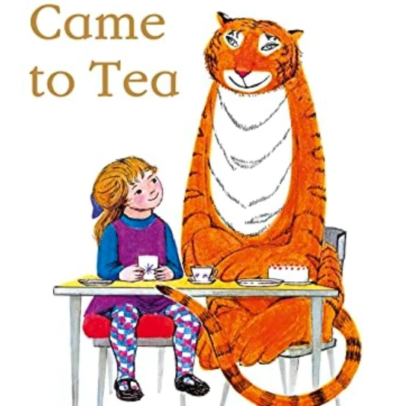
Welcome to Year 1!
Dear Parents and Carers,
We hope you all had a lovely summer. We are so excited to welcome you and your children to Year 1! We have an exciting year ahead, full of learning, creativity, and new adventures.
We feel very lucky to be teaching such a wonderful class, and can’t wait to see the children grow in confidence and enthusiasm as the year goes on. Together, we’re going to make this a fantastic year of fun and discovery!
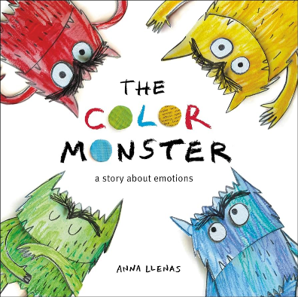
Mrs Shepherd and Mrs Morgan
Reading: We encourage children to read for at least 10-15 minutes each day at home, whether they’re reading to someone or enjoying a book independently. This daily reading practice is incredibly important as it helps them decode words and become more confident with reading. We kindly ask that you record each reading session in their reading journal. Books can be put in the basket when they need changing.
Phonics: Children will participate phonics lesson every day. Phonics is a crucial part of learning to read, and these daily sessions will help build their reading skills. Occasionally, your child may be given simple phonics activities to complete at home to reinforce their learning.
PE sessions will take place on Tuesday and Thursday. Please ensure your child is dressed in the correct PE uniform.
Monday: Please make sure your child comes to school in their Forest School uniform and brings wellies and waterproofs if needed.
Subject | Term 1
Reading | The Tiger Who Came to Tea  The Colour Monster  Open Very Carefully  Lost and Found  Poetry
Writing | Labelling, captions, sentence structure, and descriptions.  Using prepositions, adjectives, and the conjunction "and."  Writing a letter using the personal pronoun "I" and simple past tense.  Recounting the story with a focus on sequencing.  Independent writing
Maths | Place Value within 10  Simple addition and subtraction  Part and whole model  Number sentences  Number bonds to 10
Science | Identifying and naming parts of the human body.  Senses
Computing | Technology around us
Geography | Birds eye view  Map skills  Directional language
PE | Fundamentals sending and receiving
PSHE | Road safety, keeping safe.
Art | Portraits
RE | Exploring different religions, what they are and what it means to be a part of them.
Music | Active listening. Focusing on, pitch, beat, echo and singing.

