
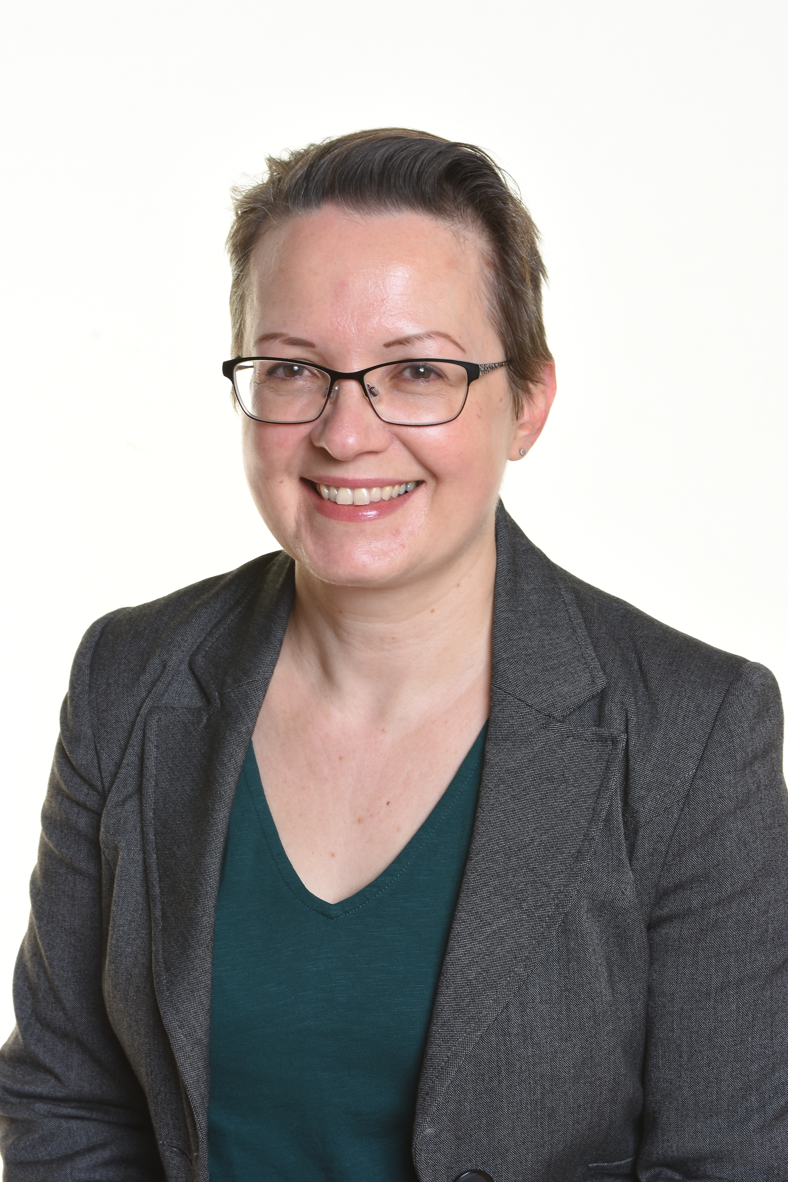

INSERT PHOTO
Who am I?
My name is Rachel Younger and I am a co-opted governor at Hillside. I am the Business Manager at a primary school in Blackpool, and I have worked in education for over 20 years.
Why did I become a Hillside Governor?
I volunteered to become a governor at Hillside so that I could use my skills and knowledge to benefit and support the school. I also see being a governor as a great source of professional development, and I have learned a lot over the years I have been in the role.
What do I bring to the governing body?
As a school business manager, I have experience in financial management, health & safety, estates, HR and administration management. Through my job, and my role as a trade union official, I keep up-to-date with current developments in education at a national and local level. I have a good understanding of the governance role and play my part in the board’s challenge / support relationship with the school’s senior leadership team.



