

Who am I?
My name is Jacq and I’m a parent at Hillside. My son is currently in Year 9. I live in the local area in Preston with my husband, 2 children and my dog, Poppy Power. I’m always happy to have a chat about my role if there are any questions.
Why did I become a Hillside Governor?
I think it’s really important for parents to be able to express their views in their child’s education, even moreso when additional needs are involved. It’s vital that parents have a voice and input into how the school can continue to provide the best educational experience for all our children.
I enjoy being a parent governor at Hillside and I am proud of the school and its achievements.
What do I bring to the governing body?
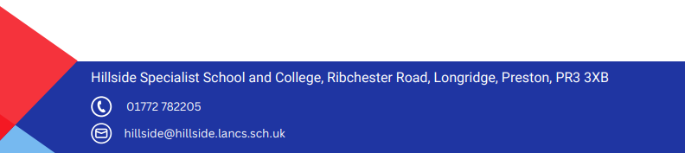
I am a vocal parent governor and believe that this is vital perspective to have on a governing board of a school such as Hillside. The perspective of parenting an autistic child and advocating for their needs in the education system is invaluable.
I also have 10 years of experience of working with children, especially in the EYFS stage and have previous training as a SENCO. I am currently the EYFS Governor in the fabulous EYFS class at Hillside.
I have also volunteered in various classes/events at Hillside for over 10 years and have a good relationship with the school and the staff.

