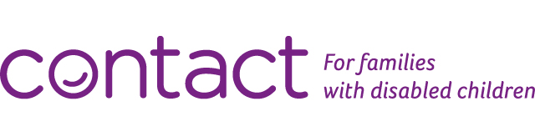
What a start to 2021. With yet another lockdown upon us why not book onto our free online sessions designed especially for parent carers.
New for 2021 are sessions on Growing Up that will explore how best to support your child as they experience puberty and adolescence. Support with managing their educational, practical and emotional needs, and helping them to develop positive relationships.
Please register beforehand by clicking the individual links:
Wednesday 20th January at 10:00 am. Book now via Eventbrite

Thursday 28th January at 10:00 am. Book now via Eventbrite

Looking after yourself

It’s never been more important to look after yourself so why not try our wellbeing session to help you understand what stress is and how it affects you. Identify new ways of coping with stress and reducing your stress levels. Try new stress busting ideas until you find ones that fit with you!
Book now via Eventbrite for Friday 22nd January 10:00 am
There are other sessions aimed to help you develop your skills for online and in-person for meetings with professionals. And sessions to support for siblings. Book a session via our Family workshops webpage

Other ways we can help
The Contact website provides advice and information about any concern you might have including a section on preparing for adult life and the latest Covid-19 information including questions and answer on the Covid-19 vaccine.
We also have an online shop full of practical products for your child such as Clear Panel Face Covering designed to help with lip-reading and social queues.
If you can't find what you need on our website you can call Contact's free helpline on 0808 808 3555 between 9.30am-5pm Monday to Friday or email helpline@contact.org.uk
Best wishes and stay safe
Una
On behalf of the Contact Team
PS Why not try your luck with the Contact lottery

