
Spruce Class Autumn Term 2026-2027
Spring Term 1 – Weather hot and cold |  | Spring Term 2 – Senses and sound
Students will also work daily on their individual ‘PLP’ Communication targets, and continue to build Literacy Skills through:
Colourful Semantics, phonics, writing and typing, Attention Autism, Story Massage and Sensory Stories, poems and songs.
 | Our stories:  Shark in the park on a windy Day  The sunny Day  Percy the Park keeper on a Snowy Day  Makaton and phonics will also be taught to the children during our daily communication sessions. | Our stories:  Senses story  The Leaf Man  Peace at Last  Stickman  Makaton and phonics will also be taught to the children during our daily communication sessions.
 | Maths  Addition and Subtraction and  Capacity and Volume | Maths  Fractions and temperature
And PSHE | PSHE-  Self-Awareness  SA1 — Things we are good at  SA4- People who are special to us (Careers link)  SA5- Getting on well with others | PSHE-  Changing and Growing  CG1. Baby to adult  CG2. Changes at puberty
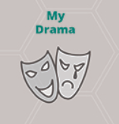  My Creativity  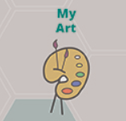   | Art:  Painting linked to seasons and weather  Music  Weather songs | Art  Artists, and creative exploration through light and sound  Music  Senses songs
 | RE -  Noah’s Ark | RE - Festivals –  Christmas in the UK.
 | Science  The Seasons- Different seasons  Geography  Weather – water | Science  Physics – light, sound  History  Cause and Consequence  Sounds in the home and school – identify different settings
 | Computing  What is a computer – key skills | Computing  Sound, music, poster and presentations
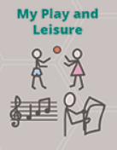 | Students will take part in structured play learning how to play group games together,  and daily free play, which will include sensory/messy play, food play, exploratory play and discovery play.  Students will also have opportunities to develop their fine and gross motor skills through play.
 | Gymnastics 1.6 – Push Me Pull Me  PE, Sport, Games and Aquatics –  My Dressing and Undressing | My Dance  Dance 1.1 – Prance and Dance  My Dressing and Undressing
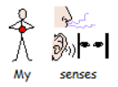 | Each child in Spruce Class takes part in differentiated Sensory Circuits, sensory exploration and play, massage and TACPAC each day. Students are encouraged and helped to access individual sensory diets, throughout their school day. Spruce Class takes part in Intensive Interaction.

