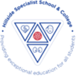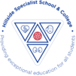
Saplings Autumn 1 2026-2027
 | Me and My Family
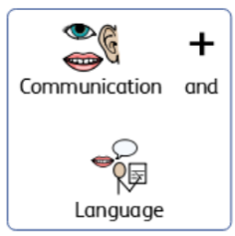 | Listening and Attention & Speaking  Children work daily on their individual ‘PLP’ Communication targets, and build literacy Skills through: daily phonics work, reading, sensory stories, poems, and songs. Children also have weekly intensive interaction and Attention Autism sessions, peer play and tac pac sessions. Communication is developed through use of a Total Communication Approach. Children’s skills and understanding supported through teaching of Makaton and use of objects of reference and a range of visuals, including choice and communication boards.  Our Key Makaton signs that we will be learning this half-term are:  Me/ myself/ I, Mum, Dad, brother, sister, Grandma, Grandad and family.
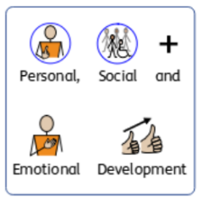 | Building Relationships, Self-regulation & Managing Self  Throughout the year we will be focusing on making relationships, developing self-confidence and self-regulation skills, and managing feelings and behaviour. Daily opportunities to develop social, independence and  organisational skills are provided through use of visual support/communication support, TEACCH, continuous provision.  Life-skills we will be focusing on this half-term are:  Hair and teeth brushing and early dressing skills.  We will also be looking at learning how to share and taking turns using the Thrive approach.
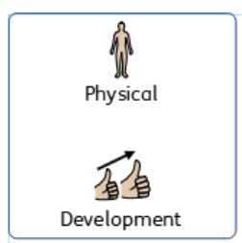 | Gross Motor Skills & Fine Motor Skills  Gross motor– In outdoor area develop climbing, running,  hopping, skipping skills, use of scooters/trikes etc. Each child will attend weekly sessions in interaction room (soft play) and have a weekly PE session on a Tuesday.  Fine motor – Holding writing tools effectively in  preparation for writing – encouraging tripod grip, using different small tools, including scissors,  paintbrushes and cutlery.  PE Focus this half term: Moving in different ways (exploring different ways of moving on, under and over different equipment and apparatus).  Use of tools – Exploring and using cutlery.
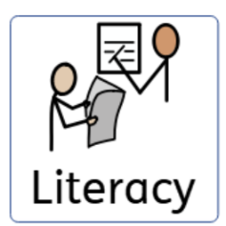 | Comprehension, Word Reading & Writing  Children will work on their individual Literacy ‘PLP’ targets and will be provided with daily reading and mark-making opportunities. They will access daily phonics sessions to develop their early reading and writing skills and explore sensory stories during our daily Literacy sessions. They will then complete group and individual activities linked to the stories to help develop their comprehension skills.  The sensory stories we will be exploring this half-term are:  -No more room for Baby Roo  -Three Friends Together  -Harry and the Dinosaurs go to School
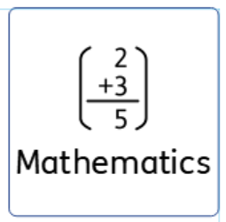 | Number & Numerical Patterns  Children will develop their number skills through structured daily math sessions, play and hands on practical activities. Daily number work will also be developed through continuous  Provision activities which will be modelled to the children by staff. Children will also be supported daily with their individual Maths ‘PLP’ targets.  Our Focus in Maths this half term is:  Number to 5 through number songs  The children will also be exploring primary colours and 2d shapes.
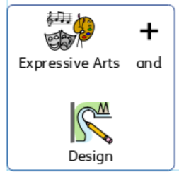 | Creating with Materials & Being imaginative and Expressive  Children will learn about media and materials, thinking about use and purpose. They engage in a variety of messy play, arts and crafts, malleable play and musical activities on our current theme. They have opportunities to engage imaginatively and present their own ideas and feelings through art and design music, dance, role play and stories.  Focus Activities to be explored this half - term will include:  Learning songs about themselves, their bodies and their families, creating self-portraits and painting pictures of their family members. Building models of their own homes using junk model materials and using a range of construction materials. The children will also have the opportunity to explore the home corner each day to develop their play skills.
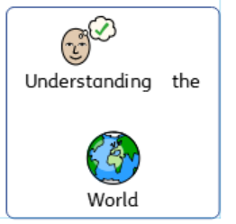 | Past and Present, People, Culture and Communities, The Natural World  This half – term the children will focus on People, culture and communities and will describe their immediate environment using knowledge from observation, discussion, stories, non-fiction texts and maps. They will learn about some similarities and differences between different religious and cultural communities in this country, drawing on their experiences and what has been read in class. The children will also be provided with opportunities to use different programs throughout the curriculum ie on the computer, interactive whiteboard, iPad, cause and effect toys and switch toys to develop their knowledge, skills and understanding of technology.  Focus Activities to be explored this half - term will include:  Looking at photos of their own and their peers’ families and pets to explore similarities and differences between them. Exploring different houses that they live in and about the areas that they live. The children will also be going on nature walks around the school grounds to explore their new environment and using the iPad to take photograph of their favourite areas.

