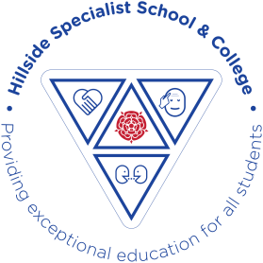
+ Autumn term Cedar class 2026-2027
 | Autumn 1 This is me | Autumn 2: Musical
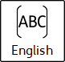 | Head to toe Eric Carle | Musical
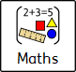 | Measure | Geometry- shape
 | Self Awareness -how do we learn? | The world I live in  WILI1. Human diversity  Wili2. Rights and responsibilities
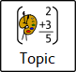 | This is me  Topic-People | Musical
 | The human body/body  parts and awareness | Exploring sounds and vibrations
 | Judaism (Story)  Jewish Creation Story | Christmas around the world
 | Computing Link: What is a computer?  Programming & Algorithms | Computing Link: Communication: Multimedia  Suggested Units: Films; Photos
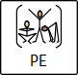 | Boccia | Dance
 | Supporting Aspirations- independent living- looking after myself  Exploring Aspirations- Section 7: My personal identityMy personal identity | Supporting Aspirations- looking after myself  Exploring Aspirations- The environment

