Using what you have learnt about area this week, read the instructions below carefully and have a go at finding out how many squares were in the shapes before the bit was torn out.

Problem 1
Jason's class cut out rectangles and some shapes which were two rectangles joined together from one centimetre squared paper.
They then counted how many squares the shapes took up.
After this they tore a piece out of some of their shapes to make a puzzle for the other groups to do.
Can you work out how many squares there were in these shapes before the bit was torn out? The orange, blue, green and yellow shapes were rectangles. The bottom two shapes, which are pale orange and purple, were each two rectangles joined together.
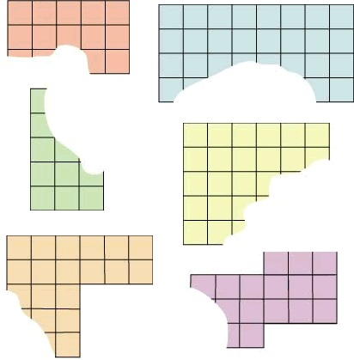

Problem 2
Now have a go at this - Courtney's group tore too much off their grey rectangle!

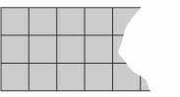

- What is the smallest number of squares it could have had?
- What is the largest number of squares it could have had if it was not longer than the longest of the other shapes?

