Thursday 25th February 2021
Can I identify and use persuasive and descriptive language?
Starter
Start off with this comprehension activity. Remember, it is important to answer the question in a whole sentence e.g. I think the _____ crayon is the angriest because…
1. Which one does Purple Crayon not have to colour?
a) Dragons b) Wizards' hats c) Apples
2. What makes Purple Crayon feel crazy?
3. What word tells us that Purple Crayon does not like messy things?
4. What does Beige Crayon think is not fair?
5. What does Beige Crayon think is a boring thing to colour?
6. How do you think Duncan might feel after reading all those letters?
Main Task
What does it mean to persuade?
Discuss what the word ‘persuade’ means with an adult. Think about how the crayons try to persuade Duncan. Can you think of any other words for persuade?
The children might come up with words such as: encourage; convince; win over; push; promote; urge.
Re-read the story and as you do, try to be detectives and identify examples of persuasion. What does this crayon want to persuade Duncan to do? What words does the crayon use in the letter that might get Duncan to behave differently?
Can you spot any other methods that the crayons use to try and persuade Duncan, for instance anything about the way that the text is written or laid out?
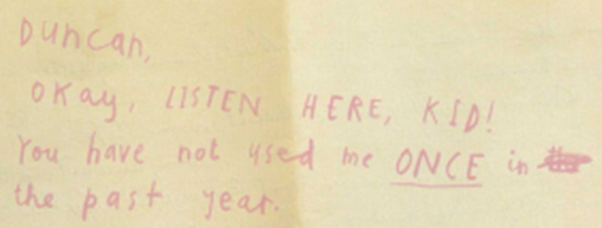
Task
Today we will be selecting a class colour, a colour that represents Year 2. Your job is to write a paragraph to persuade your teachers to pick your chosen colour as the class colour.
Why is the colour you have chosen the best? Make a short list giving reasons why your colour is the best colour.
e.g. Pink is the best colour because it is bright and bold
It can be used to draw some beautiful pictures
Pink crayon is only used once a year on Valentine’s Day
It is important to try and use persuasive language in your writing. Here are some examples:
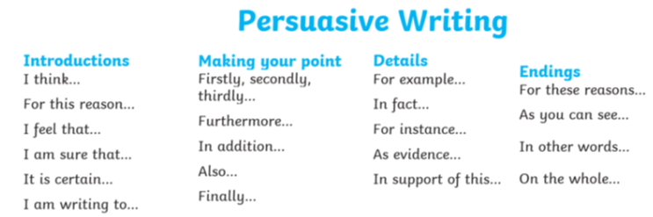
Example of a persuasive paragraph:
I feel that Pink Crayon has to be our class crayon. I am sure that you will agree with my points Mr Ingram. Firstly, Pink Crayon is never used like the other crayons. I think that it deserves more of a chance. Also, Pink crayon is such a bright, bold and colourful crayon. For instance, it is the colour of the flowers in my garden and they are beautiful. I feel it should be given the chance to stand out and represent our class. For these reasons I think you should pick Pink Crayon as the class crayon.
Success criteria
- Make sure to use capital letters and the correct punctuation
- Produce beautiful handwriting with lead-ins to every letter
- Decide on a colour
- Explain why the colour you have chosen is best
- Use persuasive language
Read your persuasive letter to a parent. Can you spot any mistakes/errors? Can you make any improvements?

