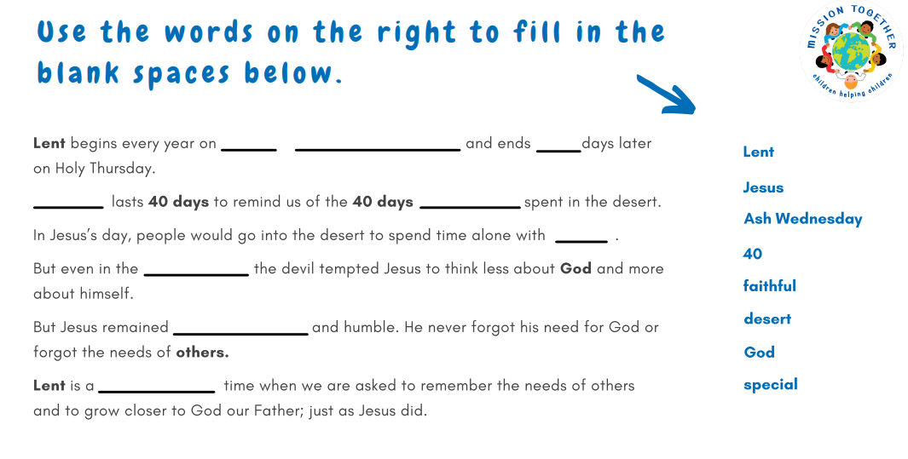
RE Lesson
Tuesday 23rd February

