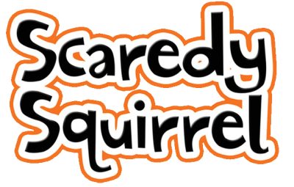
Tuesday 23rd February 2021

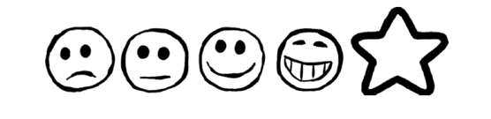
Can I use my own ideas to write my sentences?
Can I use my sounds to spell my words?
Can I write all my words on the lines?
