Wednesday 10th February

Please read the text (attached in uploads) for today’s lesson. If you have the book it is Chapter 11. Read to page 147.
Here is the link to watch it on YouTube: listen up to 6.21.
https://www.youtube.com/watch?v=WKqQ815bSUU&safe=active

Main Lesson
Today we are going to start writing our newspaper report. Yesterday we wrote down the features which we need to include in a newspaper report and we came up with a Newspaper name and title for the report also.
Get these ready for today – you will need them.
Attached as a document (or you can draw it yourself in your book) is a template you can use for your newspaper report.
It will have spaces to include the different features we looked at yesterday.

Task
The first thing you will need to do is write down your ideas for the name of your newspaper and the title of your report that you collected yesterday. Please write this on your blank newspaper report template.
This is what the template should look like.
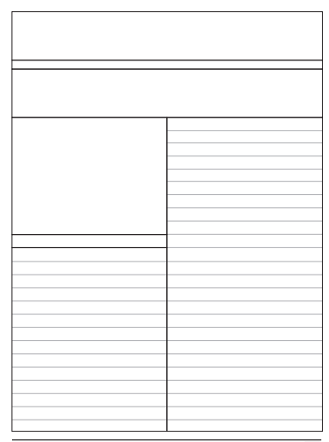
Newspaper Name

Title for report/Headline

Picture
Facts about the main event.
Caption

Picture with
caption

You are going to write your ideas down in your book not on your Template.
Can you write down your ideas which you have read about in the story for what Thors’day Thursday is all about in the Hooligan Tribe?
You could write your ideas as a list in bullet points or around a thought bubble.
Try and include the following ideas in your writing:
- Where does the Thors’day Thursday take place?
- What kind of event is it?
- Who takes part in Thors’day Thursday?
- Can you name some of the characters in this year’s event?
- What do the Vikings have to do in the event?
- What are the boys expected to do with their dragons?
- Will there be many people watching?
- What happens if the boys do not pass?

Success Criteria
- Write your ideas for your report in your book.
- Use bullet points in a list or ideas around a thought bubble.
- Use the questioning above to help to write about Thors’day Thursday.
- Write your Newspaper Name and headline on your report.
- Send a picture of your work so far on SeeSaw.

