How to use an Escalator Safely

Britain's first moving staircase was installed in Harrods in November 1898.

Although this is now old technology, it is still common to see a range of warnings and instructions to keep users safe.

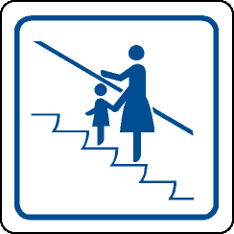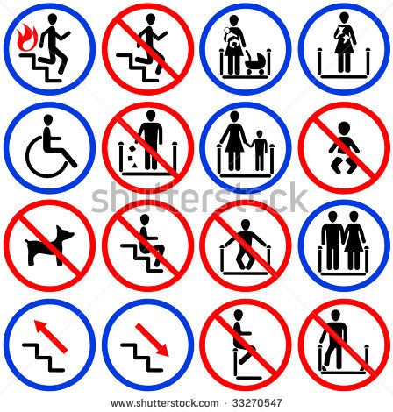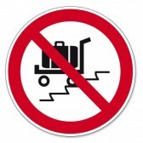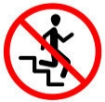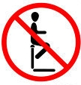

Task
- Make a list of instructions for safe escalator use.
(Use the symbols above and your own ideas.)

Collect ideas
- Talk about your ideas with a partner.
(You can act out each step to help you think of ideas.)
- Make a note of each rule.

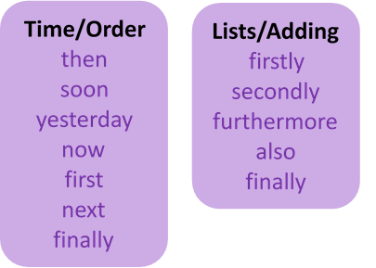
Write instructions
- Write an introduction sentence, explaining what the instructions are for.
- Next, start each instruction on a new line.
(Use adverbs to clearly link the instructions.)

Check
Reread, checking for sense and punctuation.

