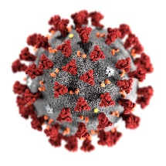
COVID-19 Pandemic - Good and Bad Times

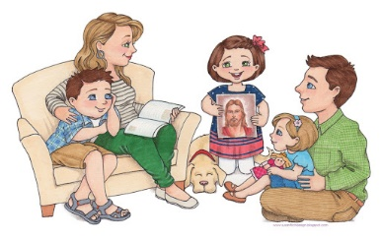
Good Times Bad Times

________________________________________________________________________________________________________________________________________________________________________________________________________________________________________________________________________________________________________________________________________________________________________________________________________________________________________________________________________________________________________________________________________________________________________________________________________________________________________________________________________________________________________________________________________________________________________________________________________________________________________________________________________________________________________________________________________________________________________________________________________________________________________________________________________________________________________________________________________________________________________________________________________________________________________________________________________

