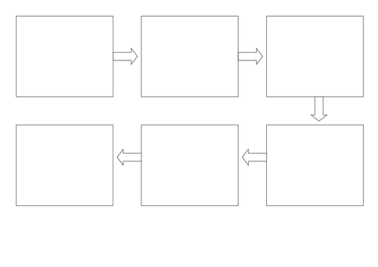
Can I use my own ideas? Can I talk about the beginning, middle and end of my story?
My Little Red Riding Hood Story Map by ______________ Wednesday 10th February 2021

