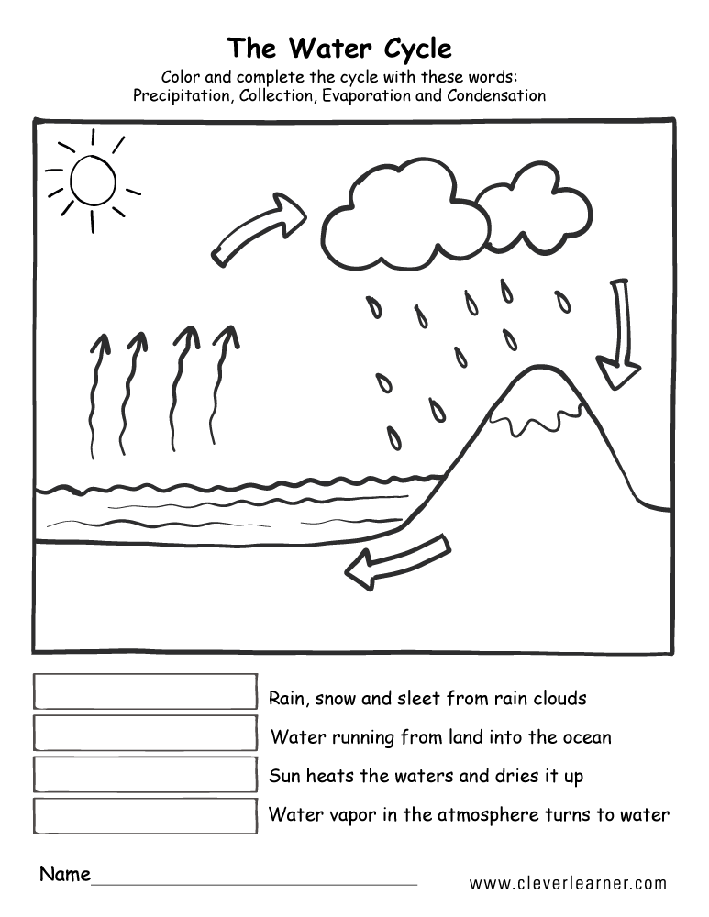
The Water Cycle
Colour and complete the cycle with these words:
Precipitation Collection Evaporation Condensation

