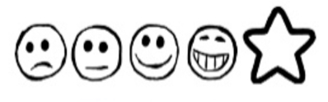
Monday 8st February 2021 My Menu

Can I think of my own ideas?
Can I use my sounds to spell my words?
Can I form my letters correctly?
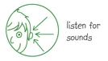
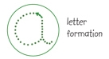


Starter

Main Course

Pudding

