Wednesday 3rd February 2021. My Wanted Poster

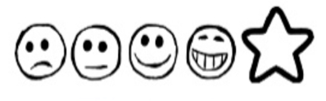
Can I use my own ideas to write sentences?
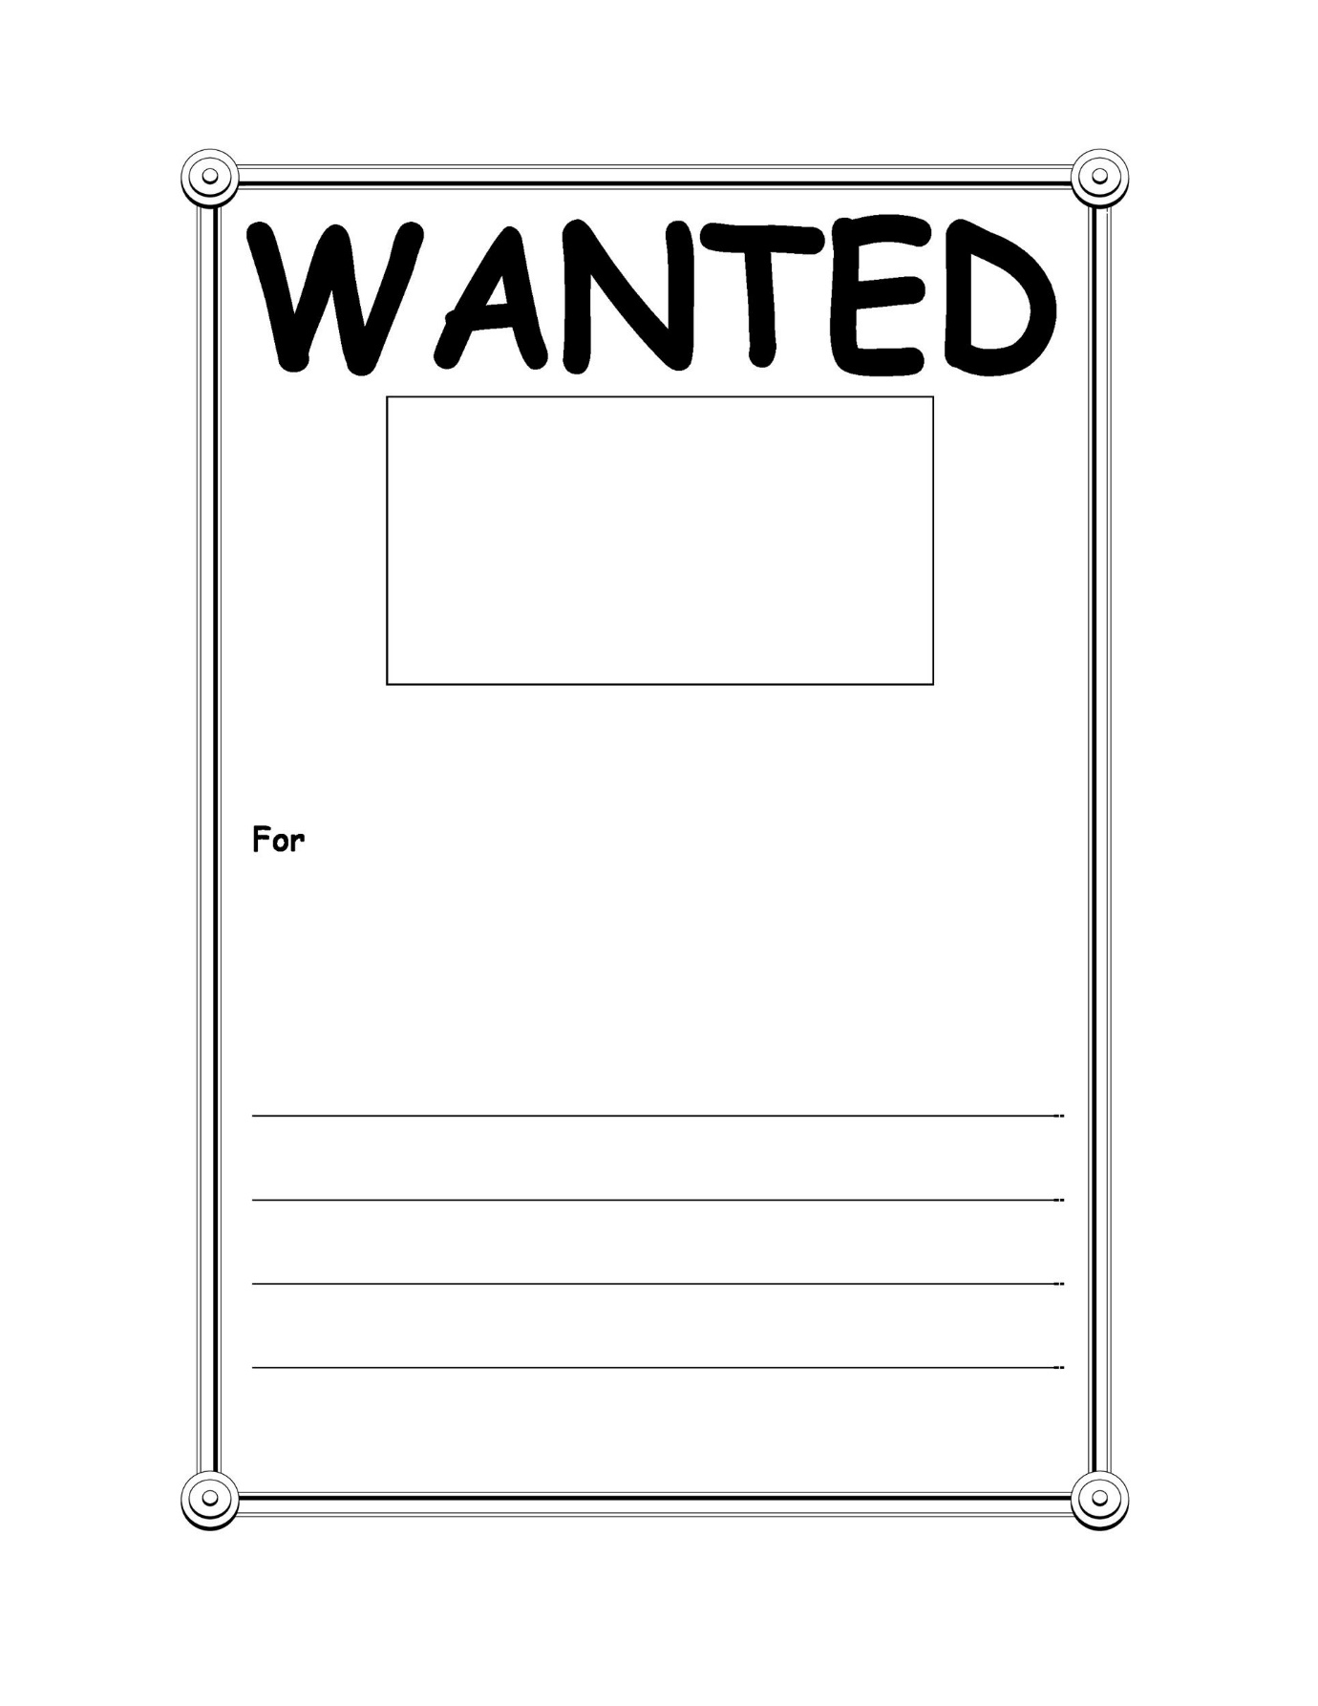
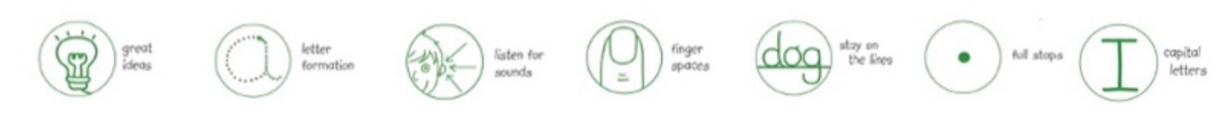
Can I use my sounds to spell my words?

