Monday 1st February

Please read the text (attached in uploads) for today’s lesson. If you have the book it is Chapter 7. Read to page 89.
Here is the link to watch it on YouTube: listen up to 7.06.
https://www.youtube.com/watch?v=auxzHNjoGJ0&safe=active

Starter
Have a go at writing your first and second name using VIKING letters.

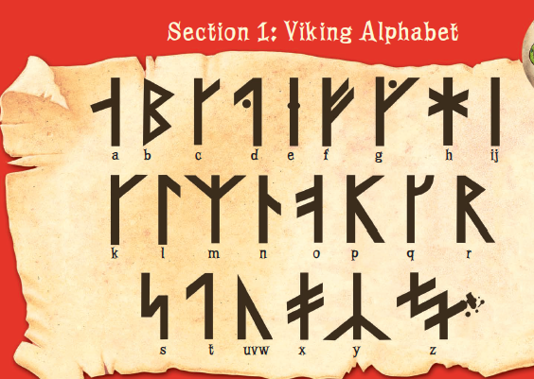

Main Lesson
Today we are going to write a note to your friend using the Dragonese language.
Please read the following phrases with you mum from the story as your starter.
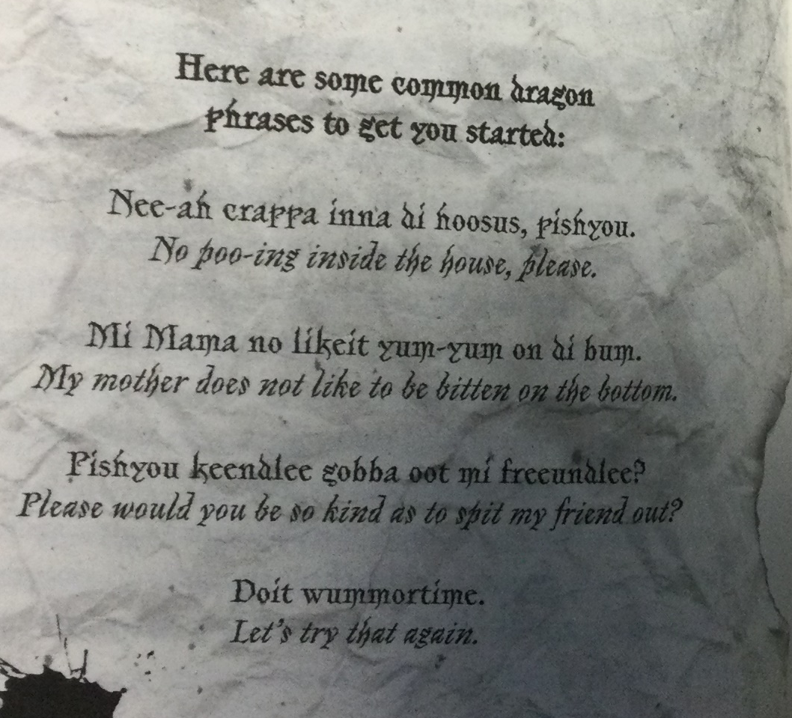

Task
To write a note to your friend using phrases in Dragonese. All the phrases have been attached as a separate document labelled DRAGONESE DICTIONARY.
You can write a nice message to your friend about what you have been doing. Maybe a walk you have been on or what you are having for your tea. You can even make it a bit silly if you want – That’s what toothless and Hiccup do.
Read through the Dragonese dictionary and pick out some of the words that you like.
Make sure you pick out words to join your sentence together.
Here’s Miss Bennison’s:
Farin Okey (how do you do). Me (I) is (am) belly scream (hungry).
Me needy oodle of chocklush.
If there isn’t a word you want you can write the English word like I wrote ‘of’.

Success Criteria
- Write about 6 sentences using DRAGONESE.
- Use the words from the dictionary to help you write your sentences.
- Use lead – ins for your letters.
- Use capital letters, finger spaces and full stops.

