Find a faraway setting for your story
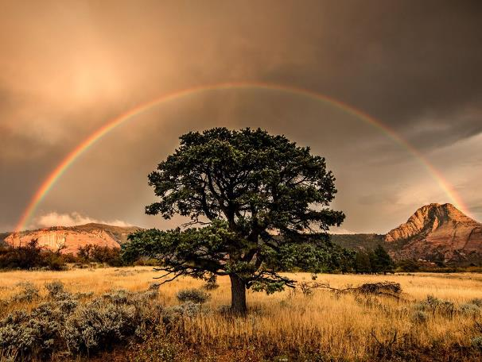 | 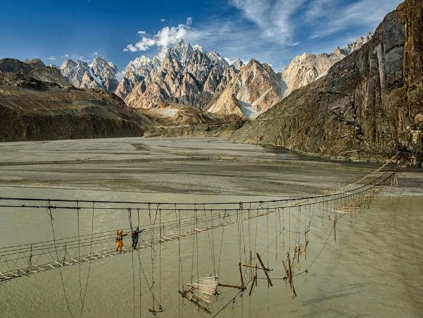
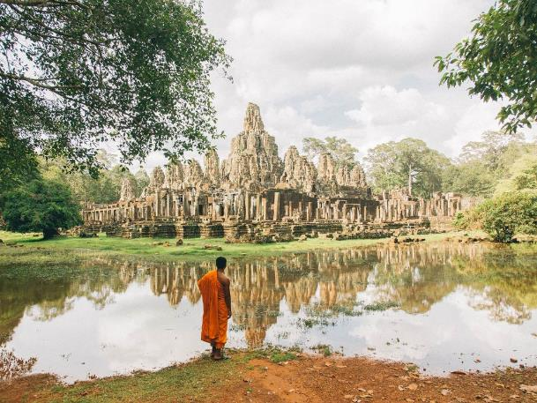 | 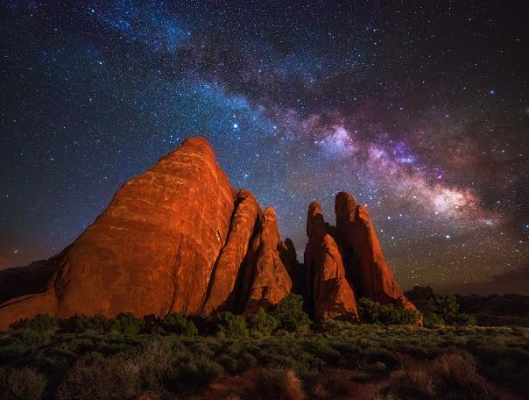
Unit 5 Day 1
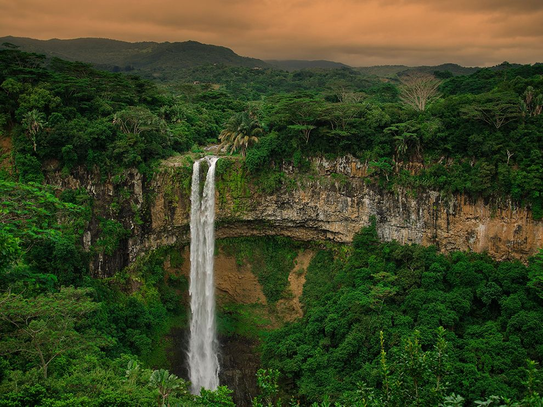 | 
 | 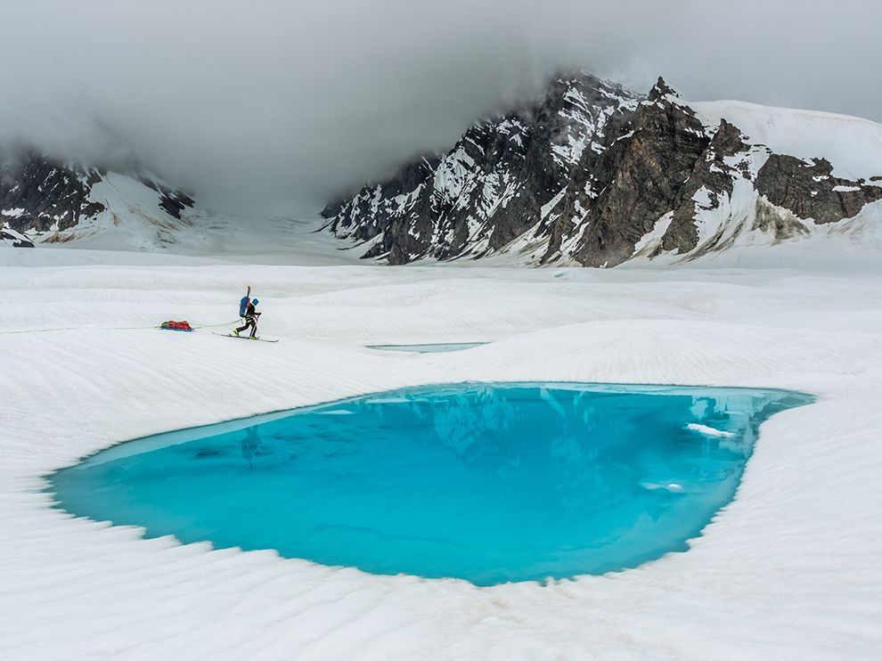
http://photography.nationalgeographic.com/photography/photo-of-the-day/landscapes/ Unit 5 Day 1
A story in (about) 100 words

Ramaema lives in the rainforest.
She sees people (farmers and loggers) destroying the trees.
Her grandfather is angry because when the trees are gone, they will starve.
The forest people and the farmers and loggers fight.
A woman called Jane comes to study the forest people, their knowledge of plants and their way of life.
Then a man who used to live in the village comes back to talk about a project.
He tells them that many people want to save the rain forest.
Tourists want to see the forest. Their money will help pay to keep the farmers away.
The villagers agree to help with this project. [108 words]

Based on The Vanishing Rainforest by Richard Platt and Rupert van Wyk

Unit 5 Day 2

