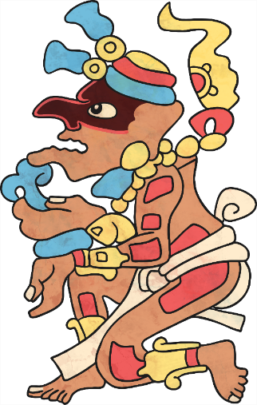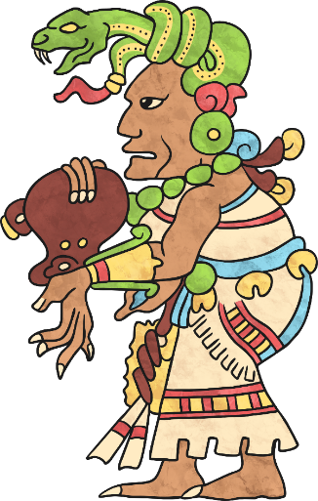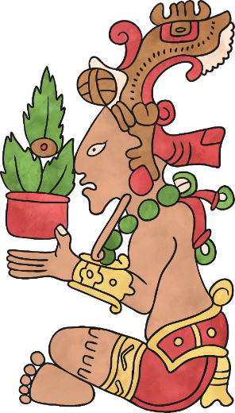
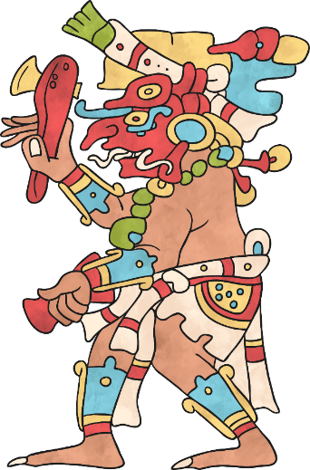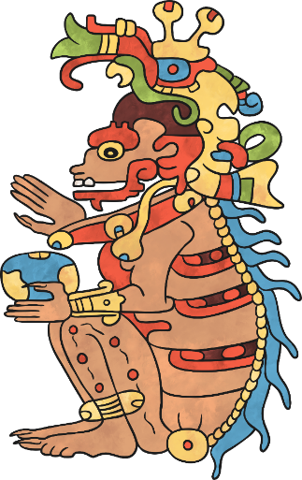

Maya Gods Fact File
Interesting Facts about the Maya religion: ______________________________________________ ____________________________________________________________________________________________ ______________________________________________
Maya Gods: ________________________________________________________________________________________________________ ________________________________________________________________________________________________________ ________________________________________________________________________________ _____________________________________________________________________ _____________________________________________________________________
______________________
______________________
______________________
______________________
______________________
______________________
____________________________________________________________________
______________________
______________________
______________________
______________________
______________________
______________________
____________________________________________________________________
______________________
______________________
______________________
______________________
______________________
______________________
____________________________________________________________________

