Can I round to the nearest hundred?
Fill in the number line, circle your number and then circle the hundred that it is closest to.
- 460
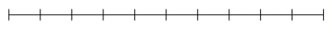
- 490
- 210
- 570
- 830
- 680
- 970
- 540

