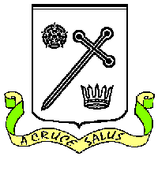
St Oswald's Catholic Primary School St Oswald’s Catholic Community:
Headteacher – C.J. Hough With Christ at the centre of our

Chapel Lane community, our mission is to live,

Longton love and learn as Jesus taught us.
Preston PR4 5EB
Email head@longton-st-oswalds.lancs.sch.uk Tel: 01772 613402
bursar@longton-st-oswalds.lancs.sch.uk

5th June 2026

Dear Parents of Y6 children,

We have organised for a company, Guardian Medical, to deliver an age-appropriate first aid awareness course on Friday 12th June.

We are committed to preparing our children for the world beyond the classroom. We know that basic first aid knowledge can make a life-changing difference, and this hands-on session is a great way to equip your child with essential life skills (please see flyer attached).

If your child has any specific medical requirements (e.g., allergies to plasters, dressings, or latex), please contact the school office directly so we can make safe, alternative arrangements for them.

This is an OPT-OUT process therefore all Y6 children will take part in this training session. If you do not wish for your child to take part, please contact the school office or email.

We look forward to seeing our Year 6s become the next generation of first aid superheroes! If you have any questions regarding the training, please do not hesitate to contact me.

Yours sincerely

C.J. Hough
Headteacher

