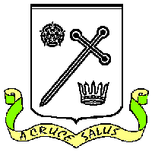
St Oswald's Catholic Primary School St Oswald’s Catholic Community:
Headteacher – C.J. Hough With Christ at the centre of our

Chapel Lane community, our mission is to live,

Longton love and learn as Jesus taught us.
Preston PR4 5EB
Email head@longton-st-oswalds.lancs.sch.uk Tel: 01772 613402
bursar@longton-st-oswalds.lancs.sch.uk

4th June 2026

Dear Parents of Y5 children,

The week commencing the 8th of June will be RSHE (Relationships, Sex, Health Education) week in school. Please find enclosed the lesson plans for the unit your child is going to cover in their Relationships and Sex Education unit, which is now statutory. You are being given the content of the lessons so you can see first-hand what your child will be covering in the lesson w/c 8th June.

The children will be taught by Mrs Whitworth for their RSHE lessons, the children will be taught as a class (boys and girls will not be separated).

If you wish to discuss any of the content of the lesson, please get in touch with myself or Mrs Whitworth by Monday the 8th of June.

Yours Sincerely

C.J. Hough
Headteacher

