ST OSWALD’S CATHOLIC PRIMARY SCHOOL
MISSION STATEMENT

With Christ at the centre of our community,
our mission is to live, love and learn as Jesus taught us.

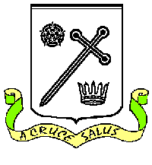

Catholic life, Religious Education and Collective Worship Parental Survey

Thank-you for taking the time to complete the survey below and overleaf as we continually look at ways to improve.

Name : ______________________________________ (optional)

Year Group of child/children: _____________________

To what extent do you agree with the following statements. |  | Strongly agree | Agree | Neither agree nor disagree | Disagree | Strongly disagree | Don’t know/not applicable
CL1.2 | My child is happy at this school
CL1.2 | My child feels safe at this school
CL1.5 | This school enables my child to behave respectfully
CL2.3 | This school is a supportive and joyful community
CL2.5 | Staff at this school are positive role models for my child
CL3.3 | The school works well with the local parish(es)
CL3.4 | I understand the school’s Catholic mission and I am supportive of it
CL3.4 | The school supports me in my role as the first educator of my child
RE1.4 | My child enjoys learning in Religious Education lessons
RE1.9 | I know how well my child is doing in Religious Education and how to improve
RE2.6 | The school supports my child’s spiritual and moral development
CW2.9 | I am invited to be involved in the prayer life of the school

Is there anything else you would like to tell us about Catholic life and mission, religious education or collective worship at the school?

