ST OSWALD’S CATHOLIC PRIMARY SCHOOL
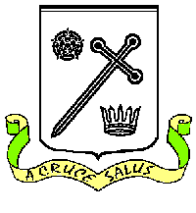

PTFA ‘TOUGH KIDDER’ SPONSORED EVENT
Thursday 5th June 2025
2.15PMa2.2.15
2
krjierrat 2.15 pm
Child’s name: …………………………………………………. Year ……..………
Name of Sponsor | Sponsorship Amount


Total amount raised ……………………………………………..

