Progression in Written Division | Stage 1  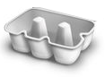  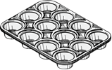  Children are encouraged to develop a mental image of the number system in their heads to use for calculation. They should experience practical calculation opportunities involving equal groups and equal sharing.  They may develop ways of recording calculations using pictures.  A child’s jotting showing halving six spots between two sides of a ladybird.  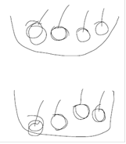  A child’s jotting showing how they shared the apples at snack time between two groups.   | Stage 2  Children explore practical contexts where they share equally and group equally. 6 ÷ 2 = ?  Equal sharing (6 shared equally between 2)  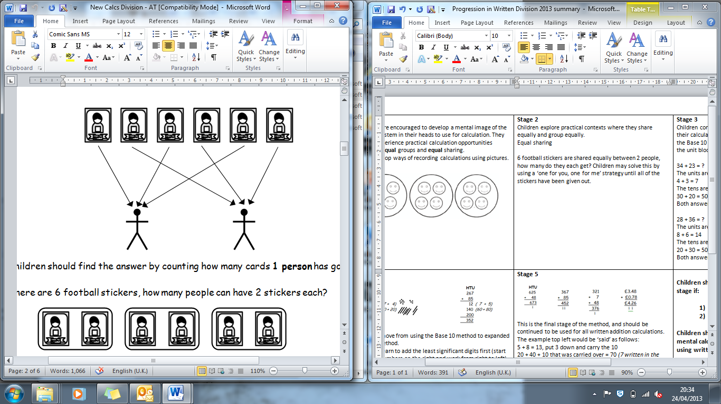  6 football stickers are shared equally between 2 people, how many do they each get? Children may solve this by using a ‘one for you, one for me’ strategy until all of the stickers have been given out.  Equal grouping (How many groups of 2 are there in 6?)  There are 6 football stickers, how many people can have 2 stickers each? | Stage 3  Children continue to use practical equipment to represent division calculations as grouping (repeated subtraction) and use jottings to support their calculation.  12 ÷ 3 = ? Children begin to read this calculation as,  ‘How many groups of 3 are there in 12?’  At this stage, children will also be introduced to division calculations that result in remainders.  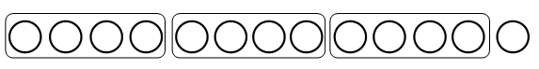  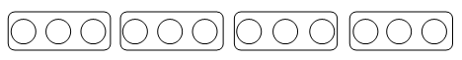  13 ÷ 4 = 3 remainder 1
Progression in Written Division | Stage 4  43 ÷ 8  43 ÷ 8 = 5 remainder 3  At this stage, children also learn if the remainder should be rounded up or down e.g. 62 ÷ 8 = 7 remainder 6  I have 62p. Sweets are 8p each. How many can I buy?  Answer: 7 (the remaining 6p is not enough for another sweet)  Apples are packed into boxes of 8. There are 62 apples. How many boxes do I need?  Answer: 8 (the remaining 6 apples still need to be placed into a box) | Stage 5  The previous method of repeated subtraction on a number line is continued, but using a vertical number line alongside practical equipment.  The repeated subtraction is made more efficient by subtracting ‘chunks’ of the divisor.  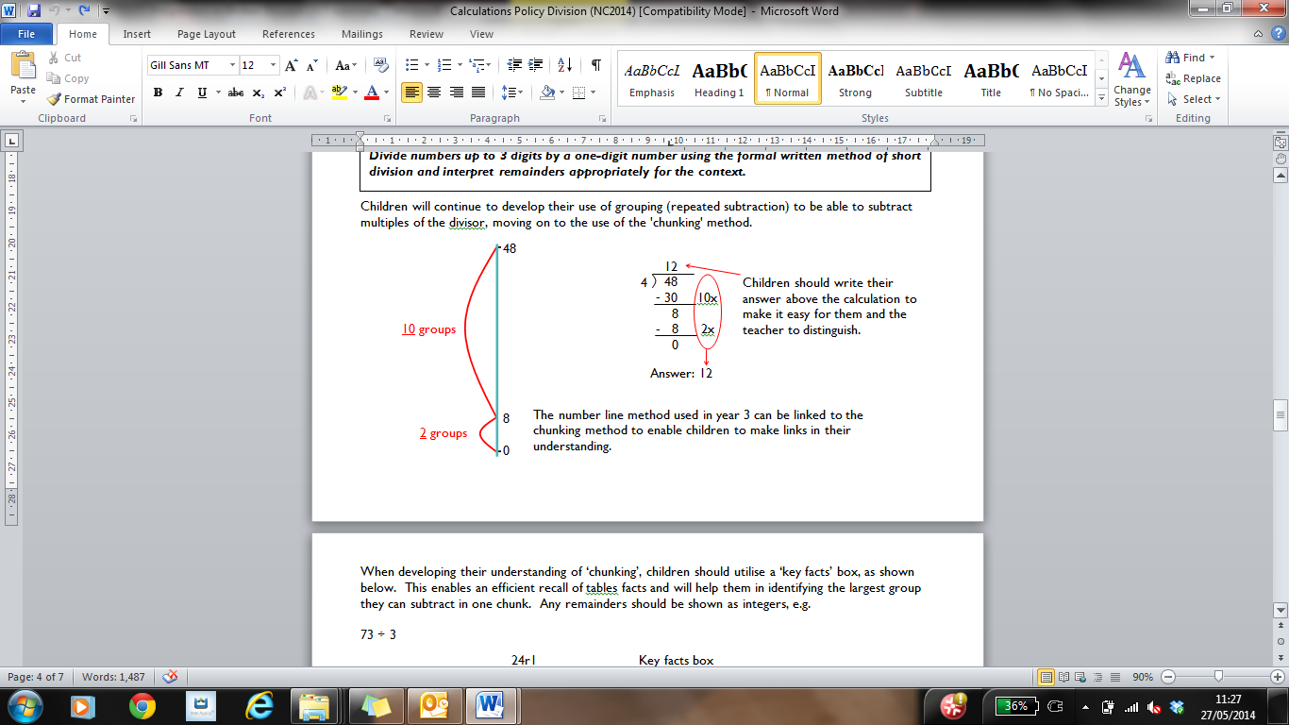  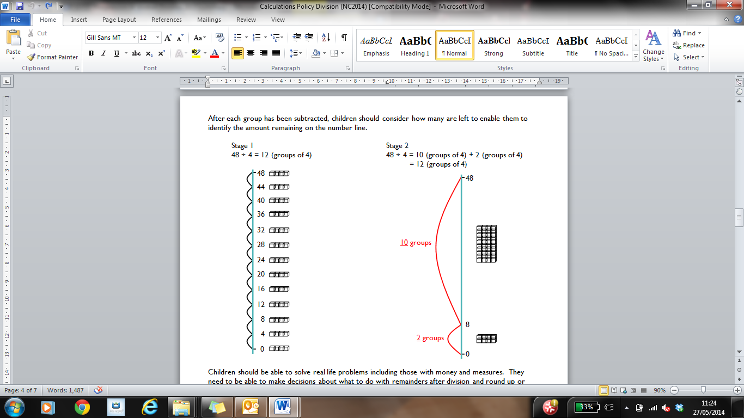 | Stage 6  This is the ‘chunking’ method of division in which children use key facts of the multiplication tables of the divisor.  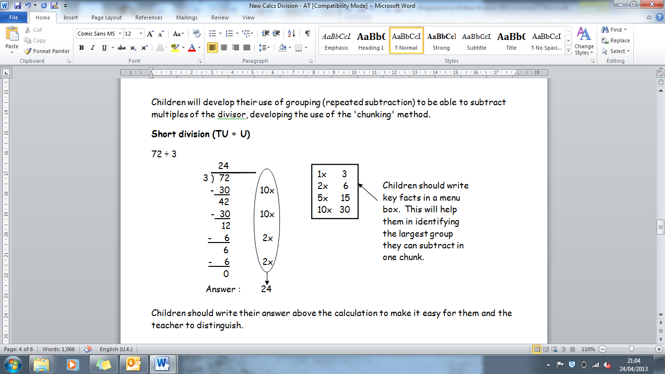

Progression in Written Division | Stage 7  During this stage children should become more efficient when using the chunking method by not having any subtraction steps that repeat a previous step. For example, when performing 196 ÷ 6 an initial subtraction of 60 (10 x 6) and two further subtractions of 60 (10 x 6 each) should be changed to a single subtraction of 180 (30 x 6).  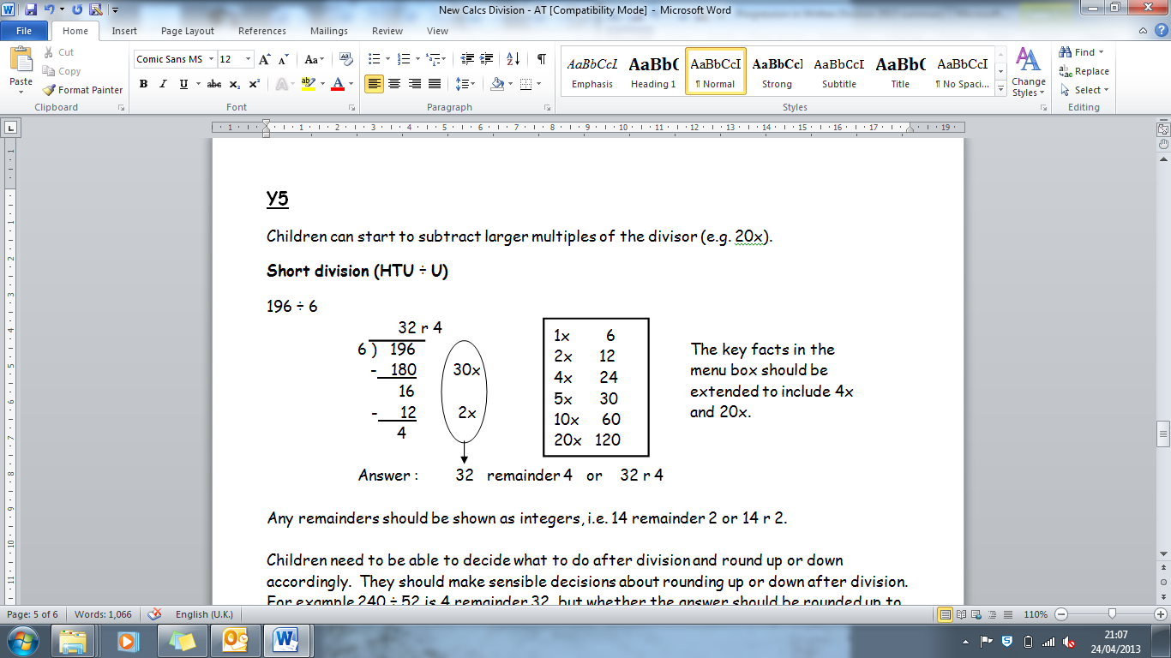 | Stage 7 continued  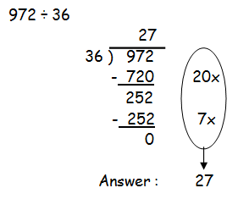  Key Facts box  1x 36  2x 72  5x 180  10x 360  20x 720  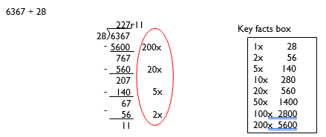
Progression in Written Division | Stage 8  When children are confident, they can use the more efficient compact method when dividing by a 1 digit number  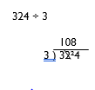 | Children should not be made to go onto the next stage if:  - they are not ready.  - they are not confident.  Children should be encouraged to consider if a mental calculation would be appropriate before using written methods.

