Granby and Dingle Children's Centre


Things to do before you start school
- 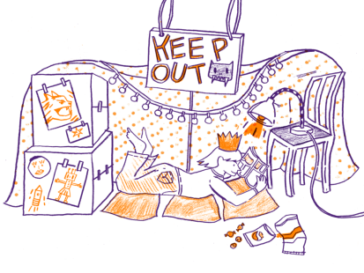

Granby and Dingle Children's Centre

About this Challenge:

School Readiness is about more than counting and recognising letters and numbers. It is all about developing curiosity and a love of learning. These activities have been carefully chosen by Early Years teachers, support staff and practitioners who work in local schools and settings. We hope you will have fun completing them and also take the opportunity to extend your child’s vocabulary by introducing new words and making lots of time to talk about things that you do and discover!

Once you have completed and dated all of your challenges, show your booklet to Children’s Centre staff or your child’s teacher or nursery staff who will take your name and contact details.
All completed entrees will be entered into a raffle with the chance to win a star prize!

We would love to hear about your adventures of becoming school ready!
Instagram: Granbydinglecc

Granby and Dingle Children's Centre

Register at your local Children’s Centre!
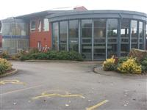

We can support you with all areas of parenting and also offer advice on adult learning, health and housing and more!
(Check out our community sessions, we run currently run sessions from Sefton Park and Toxteth library and the Florrie).
Date Completed:

Granby and Dingle Children's Centre

Join your local library online!


It is never too ealy to get your child’s 1st library card and start their reading jouney! Children need to understand about how stories are written and enjoy listening before they are able to learn to read themselves.
Reading regularly with your child not only improves their reading and writing, studies have shown that this also improves their mental health. (Literacy Trust 2018)

Date Completed:

Granby and Dingle Children's Centre

Send a postcard!


Lots of modern communication is electronic (text and email,) this means that children don’t often see adults writing for a purpose. Ask your child what they would like to write, maybe let the draw a picture too! Post to a family member or friend or even back to them!

Date Completed:

Granby and Dingle Children's Centre


Go on a listening walk


One of the early skills children need to be able to read and write is the ability to listen and identify sounds. Try recording traffic sounds, birds and sirens on your phone to listen back to.

Date Completed:

Granby and Dingle Children's Centre

Go on a number hunt
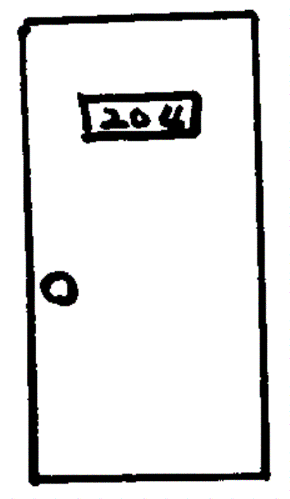

Numbers are all around us! Look at door numbers, clocks, registration plates, road signs and menu boards. This will help your child recognise numbers and also help them understand why they are important.

Date Completed:

Granby and Dingle Children's Centre

Explore local buildings!


Developing a curiosity about their community helps children learn about the world around them. Discuss what the buildings might be used for. Look at different religious buildings and talk about different religions and beliefs.
Talk about the shapes and structure of buildings to progress their maths and problem solving skills.
Date Completed:

Granby and Dingle Children's Centre

Make up a story/make your own book


Developing a good imagination in the Early Years helps child’s creativity and early writing develop. If your child needs help to get started get some props to act it out or cut pictures from magazines and make up a story together.
Date Completed:

Granby and Dingle Children's Centre

Bake a cake!


Baking can help develop lots of early skills; weighing and measuring are early maths skills and the ability to follow instructions in order helps with literacy. Try not to worry about the mess! By letting your child stir and pour you are helping them develop their physical skills and independence!
Date Completed:

Granby and Dingle Children's Centre
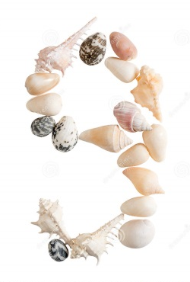
Plant a seed!

Observe what happens to the seed over a few days. What do you need to do to help it grow? This early experience will help children understand about living things and what they need to grow and will give them an interest in the natural world around them.

Date Completed:

Granby and Dingle Children's Centre


Make mud pies!

Messy and sensory play gives children the ability to express their creativity and practice their fine motor skills. Play alongside your child and notice any new words they use. Can they describe the texture of the mud? Is it sloppy, dry or wet?

Date Completed:

Granby and Dingle Children's Centre


Collect 5 different kinds of leaf



Have mathematical fun comparing the shapes and colours of the leaves. Try making a pattern and let your child’s creativity flow using leaf rubbings or printing with paint.

Date Completed:

Granby and Dingle Children's Centre


Have a Teddy Bear’s Picnic and share a snack!

Enjoy some imaginary play! Practice new words and use some mathematical language while playing with the soft toys; more, half, share etc.

Date Completed:

Granby and Dingle Children's Centre


Make a den!


Make an indoor den with chairs, blankets and string or an outdoor one with logs, leaves and tarpaulin. Den building provides an opportunity for your child to problem solve and is a great team building activity. Research shows that children are often more confident to communicate within in a cosy spaces.

Date Completed:

Granby and Dingle Children's Centre


Make Playdough!
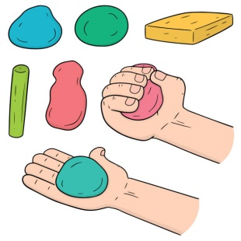
Explore what happens when you mix the ingredients together. How can you change its colour? Texture? Smell? Have fun whilst developing the fine motor skills needed for dressing and self-help and writing.
Play dough recipe:
1 cup flour
½ cup salt
½ cup water
1 tbsp vegetable oil
Few drops of food colouring

Mix the salt and flour in a bowl, add the oil. Add the food colouring then the water a little at a time and stir until the mixture can be made into a dough.
You can add other ingredients for a different texture or smell; try glitter, cocoa powder or coffee!

Date Completed:

Granby and Dingle Children's Centre


Go on a torch walk in the dark!

Develop your child’s scientific skills by exploring lights and shadows. What can you see in the sky? How are things different in the dark? Talk about what can you see, hear or smell?

Date Completed:

Granby and Dingle Children's Centre


Splash in the puddles and mud!

Outdoor play is really important to children’s development. It gives them the space to explore, develop their physical skills and learn about the world around them. If they are dressed appropriately children should go out in all weathers. Being out in the rain provides an opportunity to talk about weather, why rain is important and seasons. It also gives them a chance to jump in muddy puddles!
Date Completed:

Granby and Dingle Children's Centre


Have a gadget free day (grown-ups too!)


Technology can be fun and sometimes educational. It can however stop us from interacting with our families and friends and learning social skills. Agree as a family to one day without computer games, using social media, T.V or using a tablet. What can you do instead?

Date Completed:

Granby and Dingle Children's Centre


Visit the museum on line

We are so lucky to have free museums in the city just a click away. The possibilities for learning in the museums are endless with lots of child friendly, hands on experiences available! Check out this website for details including special exhibitions and events on all free museums and art galleries.

http://www.liverpoolmuseums.org.uk/

Date Completed:

Granby and Dingle Children's Centre

Take a bark rubbing from a tree
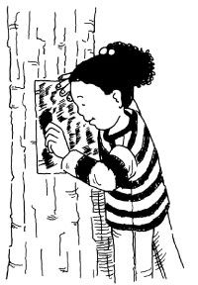
A wax crayon rolled on its side works best on a plain piece of paper. Compare different patterns from different trees and experiment with colour to develop creativity and an understanding of shape and pattern.

Date Completed:

Granby and Dingle Children's Centre


Let your child help with the shopping

Make a list together and try to incorporate some counting e.g. ‘we need 5 apples and 4 bananas’. Practice remembering information e.g. we need bread, milk and biscuits. It may be a good idea to help your child pay for one of the items with coins to develop an understanding of money.

Date Completed:

Granby and Dingle Children's Centre


Play a family game
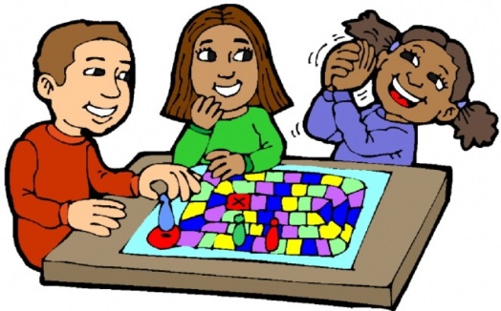
Playing a game can help children learn about rules and turn taking. Matching games like loto or card games like snap are simple and in expensive. Games like ‘I spy’ don’t need equipment at all. Try using colours or shapes e.g. “I spy something red” or “I spy something round like a circle”.

Date Completed:

Granby and Dingle Children's Centre



Practice scissor skills and make a collage.


Practice cutting skills by using making a collage from pictures in catalogues, newspapaers or magazines. Cut out letters to make words or make funny face pictures by putting different features together!

Date Completed:

Granby and Dingle Children's Centre


Make a pasta necklace
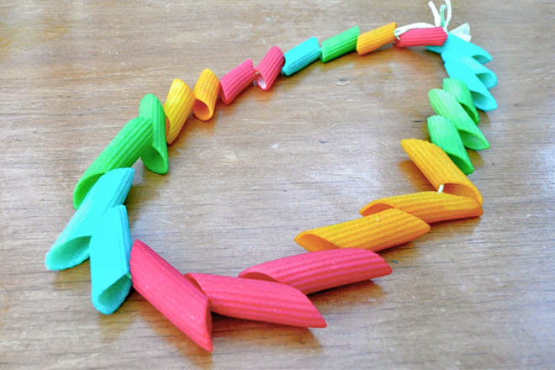

Penne pasta tubes (uncooked) are great to practice threading skills. Try using paint or glitter to decorate and thread onto string to make a necklace or bracelet!

Date Completed:

Granby and Dingle Children's Centre



Practice dressing skills-let your child choose their own clothes!


Children need to be able to dress themselves at school for lessons such as P.E. Choosing their own clothes can also provide an opportunity to talk about the weather and appropriate clothing to wear on warm or cold days.

Date Completed:

Granby and Dingle Children's Centre


Do a random act of kindness!

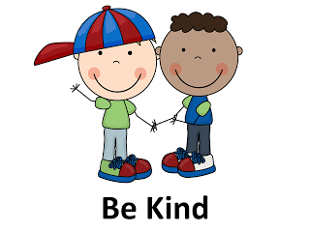

Children need to understand how their actions effect other people. Children will learn how to do this by following role models. Try checking in on a neighbour or encouraging your child to share a toy.

Date Completed:

Granby and Dingle Children's Centre


Help with the washing!

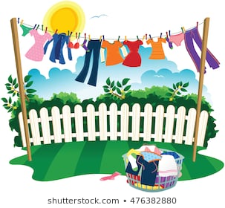
This provides lots of opportunities for learning. Matching socks and talking about patterns and size is a great maths activity. Pegging out washing is good to develop fine motor skills.

Date Completed:

Granby and Dingle Children's Centre


Play catch!

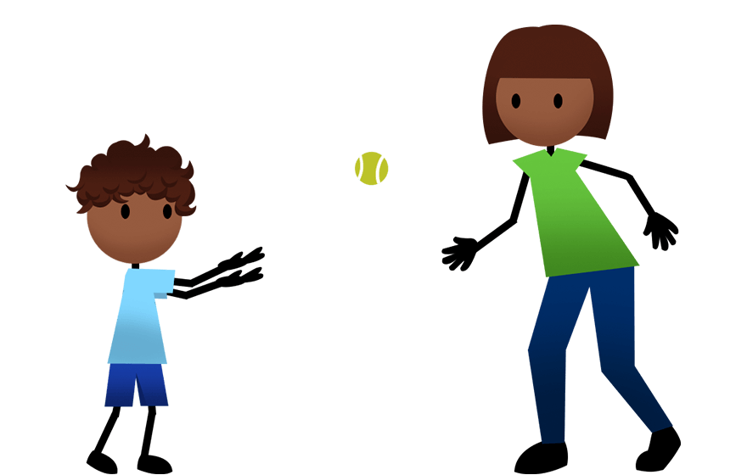

Help your child develop their physical skills and hand eye co-ordination. Start with a large soft ball initially, when they are confident move further away and use a smaller ball!

Date Completed:

Granby and Dingle Children's Centre


Record the weather for a week



This activity will help your child develop an understanding of the world around them. You can help them to draw a picture or cut one out from a newspaper or magazine. This encourages early skills in science; observing and recording what they notice. Encourage your child to make predictions e.g. ‘look at the sky, do you think it will rain today?’ This activity will also help children sequence the days of the week.
Date Completed:

Granby and Dingle Children's Centre



Practice Rhymes

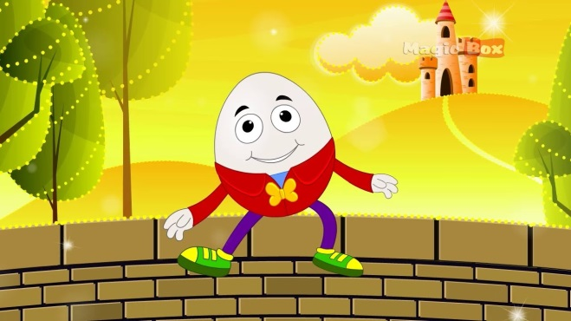

Saying and singing rhymes prepares children for reading and writing. They develop their listening skills and an understanding of how language works.

Date Completed:

Granby and Dingle Children's Centre

Experiment with water!

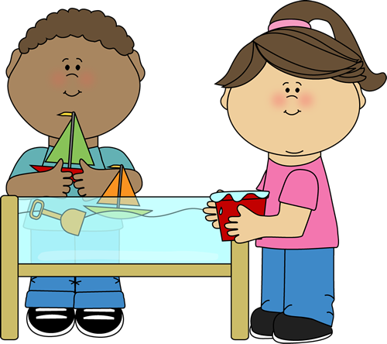

Water play provides so many opportunities for maths and science development:
- Use different sized containers to explore capacity.
- Put some water in a balloon and freeze it to discover how it changes when frozen.
- Experiment with objects to see if the float or sink.

Date Completed:

Granby and Dingle Children's Centre


Make Marks with Messy Play!

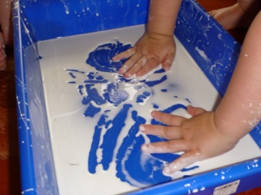

Messy Play gives young children the opportunity to develop the fine motor skills needed for writing. Try drawing, writing and making marks using shaving foam, paint or gloop (cornflour and water).

Date Completed:

Granby and Dingle Children's Centre



Read together-anytime, anywhere!



Show your child that reading is fun and can be done anytime and anywhere! Try reading outdoors, on a bus or even sat in a tree!

Date Completed:

Granby and Dingle Children's Centre


Look for signs and logos around the city.



Look at road signs, tourist information signs and logos for shops and restaurants. Does your child know what they mean? This links to pre reading and writing skills.

Date Completed:

Granby and Dingle Children's Centre


Go on a ‘natural’ treasure hunt

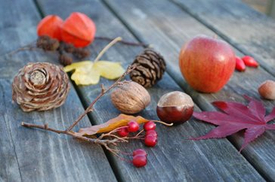

What ca you find during a walk at the park, beach or forest? Explore the texture, shape and size of natural items and talk about where they have come from.

Date Completed:

Granby and Dingle Children's Centre


Walk up a hill-explore uneven ground



Develop physical skills and balance by walking or running up a hill (rolling down a grassy hill is fun too!).

Date Completed:

Granby and Dingle Children's Centre

Blow and catch bubbles


Develop hand eye co-ordination and eye tracking skills. Encourage your child to pop the using their index finger and thumb. This helps develop the muscles needed for holding a pencil.

Date Completed:

Granby and Dingle Children's Centre


Paint a self portrait
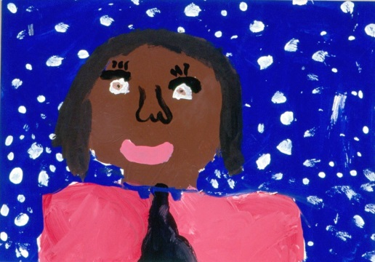

This activity helps personal, social and emotional development. Use a mirror for your child to explore their features. Do they look like anyone? What makes them unique? How are they similar or different to their friends?

Date Completed:

Granby and Dingle Children's Centre


Make a healthy lunch


Children develop their eating habits at a young age. Chat to them about which foods are healthy and which are better as treats. Children will also often be more willing to try food that they have helped prepare.

Date Completed:

Granby and Dingle Children's Centre


Get creative with a cardboard box!



Let your child’s imagination roam! Use paints, pencils or crayons to decorate. You could add pieces of fabric too. Children may decide their box is a space rocket, car or boat. They may turn it into a house for small world toys. There is no right or wrong so let them take the lead!
Date Completed:

Granby and Dingle Children's Centre


Make a musical instrument

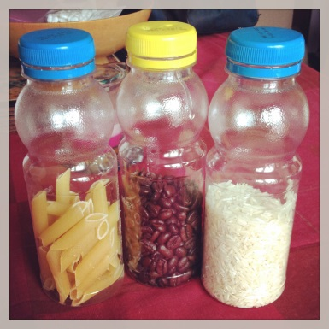

Explore sounds by putting dried beans, pasta or rice in a bottle. Elastic bands wrapped around a tissue box also make a good sound. Compare and see which materials make the loudest or softest sound.

Date Completed:

Granby and Dingle Children's Centre



Learn about a festival and how it’s celebrated.



Part of understanding the world includes the knowledge that people have different cultures, beliefs and religious practices. It can be great fun learning about a different festival!

Date Completed:

Granby and Dingle Children's Centre



Learn to say Hello in different languages

We are lucky to live in a very diverse community, celebrate this by learning some words in different languages! Children are usually much quicker at picking up new languages than adults!

Date Completed:

Granby and Dingle Children's Centre



Count cars on a walk or car journey


Choose a coloured car to count on a walk or car journey and see how many you see. This simple activity is great for practicing early maths skills.

Date Completed:

Granby and Dingle Children's Centre



Let your child help sort the recycling


This is a great opportunity to talk about different materials and their properties. It also helps your child think about how they can help look after their community and the world we live in.

Date Completed:

Granby and Dingle Children's Centre



Share different kinds of reading material.


Show your child why reading is important. Look at cook books together or instruction manuals with pictures. Find menus, comics and newspaper articles!

Date Completed:

Granby and Dingle Children's Centre



Create a piece of transient art

This involves using different objects and allowing your child to position and arrange them to create a piece of art on the table or floor. Sea shells, pine cones and twigs make good materials for this!

Date Completed:

Granby and Dingle Children's Centre



Play sequencing games.



Try giving your child a series of instructions e.g. ‘touch your head, jump up, and then turn around.’ This helps with sequencing skills and their ability to follow instructions.

Date Completed:

Granby and Dingle Children's Centre

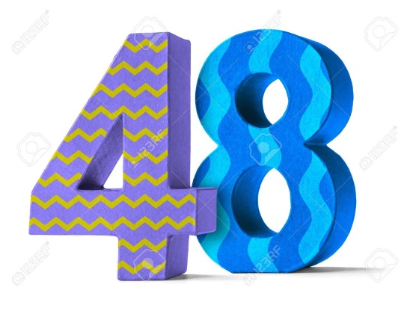

Print a repeated pattern.
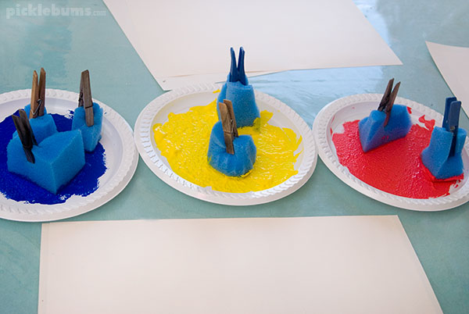

Sponges cut into shapes or potato prints are great for exploring patterns. Gradually make the task harder by adding more colours or shapes!

Date Completed:

Granby and Dingle Children's Centre



Make an obstacle course!

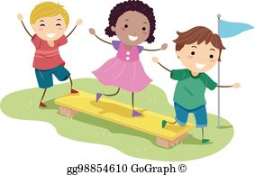

Try this at home or outdoors. You don’t need expensive equipment, just things your child can safely climb over, under or through! This helps develop physical skills and also teach your child about boundaries in which to take risks whilst also staying safe!

Date Completed:

Granby and Dingle Children's Centre



Cook on a fire!


Toast marshmallows, talk about what a fire needs to burn and how to stay safe. This can be a really social experience for children and adults alike!

Date Completed:

