4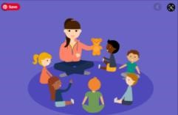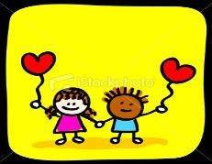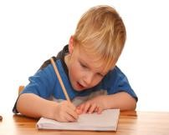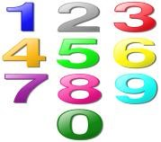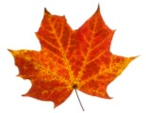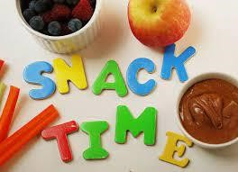

Pinehurst

Primary School

EYFS

Curriculum Newsletter
Autumn
1

2026
Nursery
-

Little Acorns

The information on this sheet
will give you a brief overview of some of the activities we will be doing this term across the curriculum.
Please feel free to contact your child’s class teacher if you have any questions or can offer any help.

Communication and Language

Learn songs and N
ursery R
hymes

Circle time to talk about self and interests.

Learning new vocabulary related to the harvest
and Autumn

Communicating when playing, learning to interact
with new children and adults.

Physical Development

Developing gross

motor (big movements)

and fine

motor (small movements)

control

Develop correct pencil grip.

Traveling/ negotiating space,
moving safely in
different ways when playing and in P.E sessions.

Learning to be independent with belongings,
clothing, toileting and food.

.

Personal Social and
Emotional Development

Focus on settling the children back into school
for Nursery returner
s and welcoming in new
children.

In our Circle time we will be thinking about:
-

How

it feels to belong and that we are
different an
d similar;

r
ecognising and
managing

feelings
;

working with others to
make school a good place, understand
ing

why
it’s good
to be kind and use gentle hands
.

Literacy
-

Reading and Writing

Book
talk, Early Reading skills, direction of
print etc.

Stories linked to themes and interests.

Giving

meaning to marks they make as they
draw, write and paint.

Begin
to recognise own name.

Maths

Learn to count up to 5 and to count objects using
one to one correspondence.

Learn rhymes counting up to 5.

Learn the days of the week and the months of the
year.

Understanding the World

Learning abou
t themselves and their families,

Talking about past experiences,
special times
or
events for family and friends.

What makes me unique?

Similarities and differences.

Autumn

and the harvest

Seasonal differences and similarities
.

Using the smart board.

Developing awareness of different technology
in the home and school.

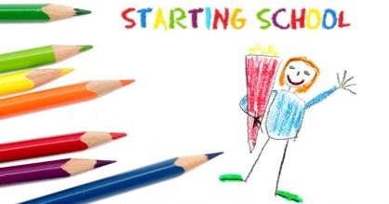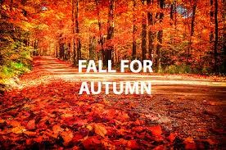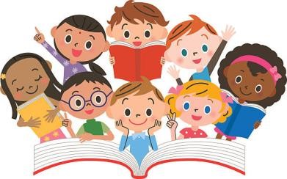
Expressive
Arts and Design

Colour mixing with a range of paints/Autumnal
colours

Self portraits
.

Pictures of family and home
.

Findin
g a steady beat
.

Using a range of percussion instruments

Our Topics this Half Term

Starting School/ All about me

Harvest and Autumn

Additional Information

We will we introducing the children to lots of
fantast
ic books here are some of them:

Starting School
Owl Babies
Books about Autumn
My Family

Important dates
Halloween – 31st October

Books about Autumn

