Summer 1 Curriculum Overview
Personal Social Emotional Development  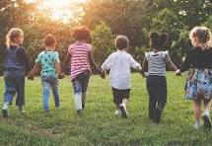  In Jigsaw Lessons our Topic is Relationships thinking about what qualities make a good friend. How to sort out minor problems and work together. | Communication & Language  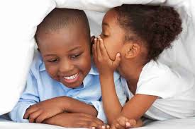  Extending vocabulary, refining listening skills, asking questions, focused listening and attention. | Physical Development  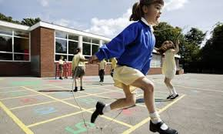  PE  Ball skills  Team games
Literacy  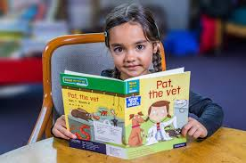  Reading the following books in shared reading The Bog Baby, Tadpole’s Promise, King of the Tiny Things, The Teeny Weeny Walking Stick as well as non-fiction books.  Daily RWI lessons  Children will be taught to write on lines with correct letter formation. | Mathematics  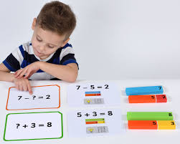  Counting on, counting forwards and backwards, counting to 20,doubling,  sharing, odds and evens, mass, volume and capacity, money, data and word problems. | Understanding the World  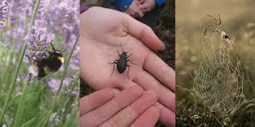  Life cycles, habitats and caring for creatures and wildlife, identifying minibeasts and birds, appreciating nature, understanding seasonal changes.
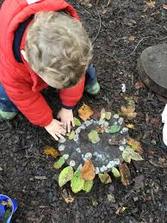 | Creative Development  Using a range of materials to collage,  Design and make a minibeast from clay.  Create a dance to music  Create a fairy world  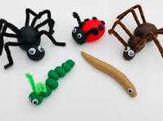 | Special Days  Earth Day 22nd  April Wear Something Green  