 Pinehurst Primary School
EYFS Curriculum Newsletter Spring 1 2026
The information on this sheet will give you a brief overview of some of the activities we will be doing this term across the curriculum. Please feel free to contact your child’s class teacher if you have any questions or can offer any help.
Communication and Language  Learn songs and Nursery Rhymes. About the seasons and time.  Learn new words and their meanings. We will talk about significant events and celebrations we have shared with friends and family.  Read a selection of stories based on our topics  Old Bear, Toys Old and New (non-fiction),The Elves and The Shoe Maker, A Year in The City, The Tiger Who Came to Tea, Cleversticks, The Three Little Pigs and The Three Little Wolves and The Big bad Pig | Physical Development  Practice scissor skills  Play throwing and catching games.  Balancing on equipment in P.E  Yoga sessions with Yoga Bears  Find out how to look after our teeth and develop good dental hygiene  How can we stay safe? Children encouraged to self-risk assess. | Personal Social and Emotional Development  Sharing news about family celebrations  Show and Share about a favourite toy  Listening to other people’s opinions  Taking turns in games and sharing  Talking about how we feel.
Literacy - Reading and Writing  Learn to listen to and recall main events from stories, picture books, traditional tales and poems. Learn to identify the key characters in a story and use our imaginations to suggest an alternative ending.  To learn letters and sounds  To begin to read words  Learn to write names and captions.  Practise pencil control. | Understanding the World  Our Topics this Half Term  Changes  Old and New  Past and Present  Melting  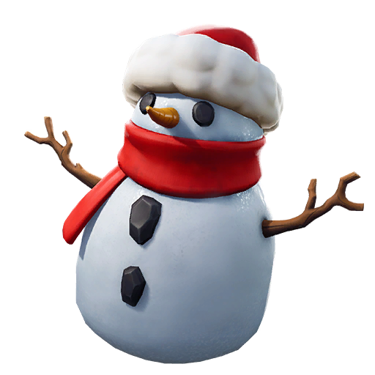 | Understanding the World  Learn all about different festivals and cultural celebrations.  What do we celebrate with our family? Differences and similarities in celebrations.  To celebrate Chinese New Year The year of The Horse Celebrations will take place in February.  Learn to use technology to support and enhance our learning.  Toys that use technology.

Expressive Arts and Design  Learn how to manipulate clay to make our own creations.  Design our own Valentine cards  Explore colour, materials and textures to create a class collage.  To learn to recognise pitch; high and low sounds. | Maths  Introducing zero  Comparing numbers to 5  Composition of 4 & 5  Compare mass  Compare capacity  Focus on numbers 6, 7 & 8  Combining two amounts  Making pairs  Length & height  Time  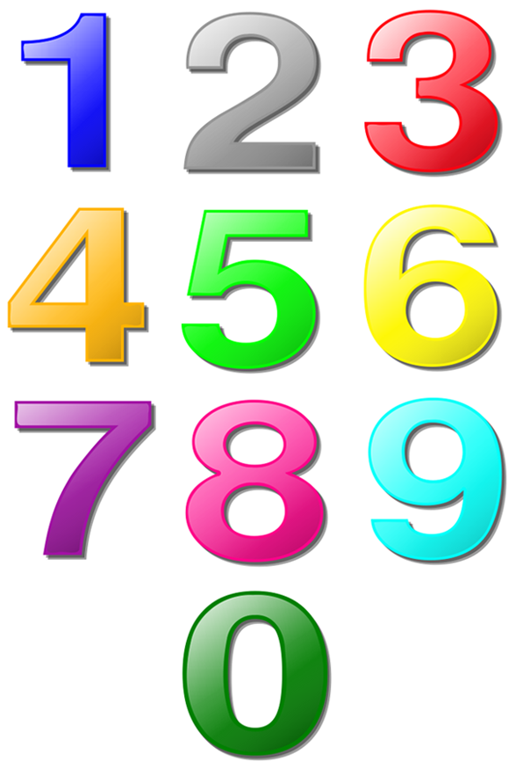 | Additional Information  We are having a big focus on books and reading,  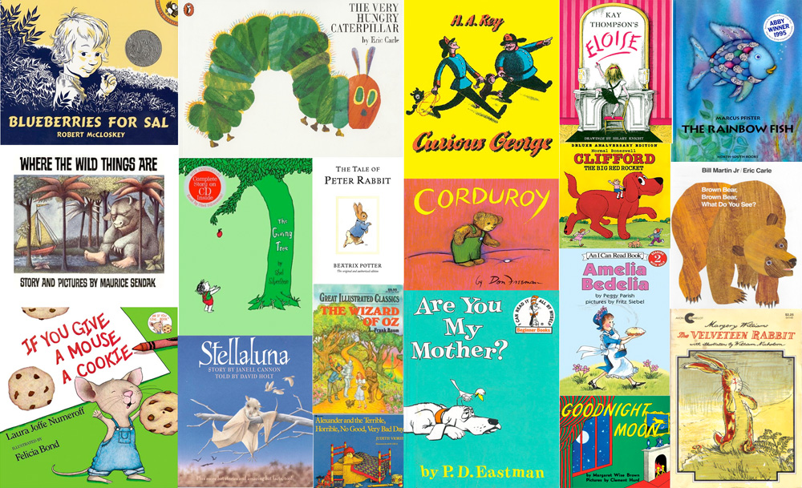  and a big focus of Physical Skills that support writing.

