 Pinehurst Primary School
EYFS Curriculum Newsletter Autumn 2 2025
The information on this sheet will give you a brief overview of some of the activities we will be doing this term across the curriculum. Please feel free to contact your child’s class teacher if you have any questions or can offer any help.
Communication and Language  Learn songs and Nursery Rhymes  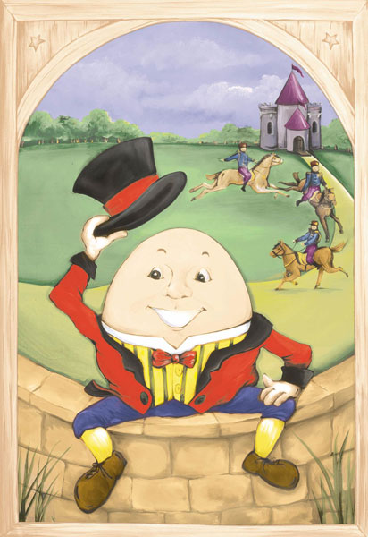  Learn new words and their meanings. We will talk about significant events and celebrations we have shared with friends and family.  Read a selection of stories based on our topics  To listen to stories about light and dark | Physical Development  How to hold pencil with a “crocodile grip” and form letters correctly.  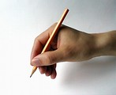  Learn how to move our bodies in a variety of ways and to move to music during our PE sessions in the hall.  To manage our hygiene independently | Personal Social and Emotional Development  Reinforce and reiterate boundaries,  To make new friends  To celebrate differences.  Learn to talk and to listen in large group situations – discuss how we need to listen to each other and to wait our turn.
Literacy - Reading and Writing  Learn to listen to and recall main events from stories, picture books, traditional tales and poems.  Key books: The Owl Who Was Afraid of the Dark, The Way Back Home, The Man on The Moon, Whatever Next, Lost and Found, The Christmas Story.  Learn to identify the key characters in a story and use our imaginations to suggest an alternative ending.  To learn letters and sounds  To begin to read words  Learn to write names and captions.  Practice pencil control. | Our Topics this Half Term  Light and Dark  Space  Metals and magnets  Festivals of Light (Bonfire Night, Christmas)  Anti Bullying Week/Odd Sock Day  Road Safety Week  Christmas | Understanding the World  Learn all about different festivals and cultural celebrations.  What do we celebrate with our family? Differences and similarities in celebrations.  Learn to use technology to support and enhance our learning.

Expressive Arts and Design  Learn how to manipulate clay to make our own creations.  Design our own Birthday and Christmas cards  Explore colour, materials and textures to create collages.  To learn to tap a rhythm on our hands and bodies. To listen to music linked to our Topics  To keep a beat on percussion instruments | Maths  To begin to estimate  Count objects 1-10  Know number names  Order and compare numbers  Find out about 2D and 3D shapes  Weigh and measure objects  Order by size  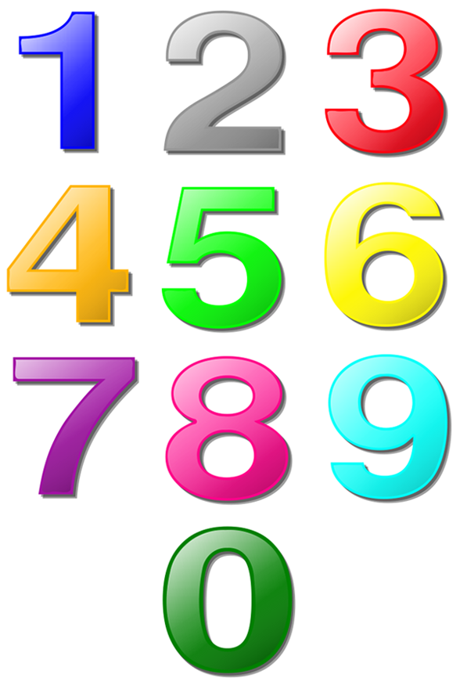 | Additional Information  We will also be thinking about the importance of sleep and bedtime routines.  