

**Meet the Teacher 2025: YEAR 6**

**Special Edition**

**THE PINEHURST PRESS**

**Experience ~ Excel ~ Enjoy**

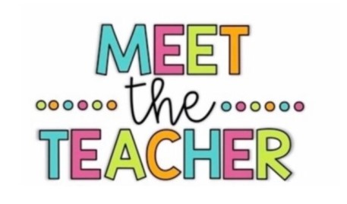

**Welcome to Year 6**

**This year the staff working in Year are:**

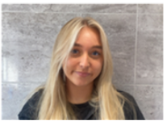

**Miss Sweeney is the teacher in Birch Class.**



**Mr Timms is the teacher in Willow Class.**

**Mrs Platt and Mrs Ivanova also work with us in Year 6.**



If you need to speak with us we are available at a distance at the end of the day.

Alternatively you may call the school office on 0151 263 1300 and we can arrange a mutually convenient time to speak on the phone.

A note into class is a helpful alternative.

For less urgent enquiries or questions please use Class Dojo.

Ms Wigelsworth, our Pastoral and Family Safeguarding Lead is available throughout the day by telephone to answer any questions or concerns.



Miss Sweeney is thrilled to be welcoming the class back as they move from Year 5 into Year 6. She is excited for another fantastic year of learning together, where the children will work hard, challenge themselves, and most importantly, have lots of fun along the way. Now in her second year as an Early Career Teacher, Miss Sweeney is looking forward to continuing the journey with her class and celebrating all they will achieve. She also leads Computing at Pinehurst Primary and enjoys inspiring children to develop their digital skills for the future.

Mr Timms has been part of Pinehurst Primary for 9 years and is delighted to be teaching Willow Class this year. He is the school’s Maths and Curriculum Lead, but his real passion lies in teaching Year 6 and supporting children as they grow and achieve. A proud Manchester United fan (despite living in Liverpool!), he also enjoys playing both golf and football in his spare time. Away from school, family is very important to him, and he loves spending time with his two young daughters, who are always keen to hear stories about Willow Class. Mr Timms is looking forward to another exciting year of learning, laughter, and new challenges with the children.

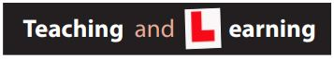

This half term the children will be learning numbers up to ten million in Maths where they will focus on reading, writing, ordering and comparing large numbers. In English our class text is *The Unforgotten Coat* by Frank Cottrell-Boyce which will inspire reading comprehension, vocabulary development and a range of creative writing opportunities. In Science our topic is Electricity and the children will learn about electrical circuits, components, conductors and insulators and how to work safely with electricity. In Geography we will carry out fieldwork in our local area focusing on land use and how our environment has changed over time. In Art the children will be developing their drawing skills taking inspiration from the work of Sir Giles Gilbert Scott. In PSHE our theme is Being Me in My World where we will explore identity, belonging and how we can work together as a class and school community. Finally, in RE we will be investigating the big question: What do religions say to us when life gets hard?

Please also see our half termly curriculum newsletters for helpful information about our current topics in school. These can be found on our school website – **www.pinehurst-primary.co.uk**



Home Reading every day is important. Please complete your child’s reading record every time they read at home and return this with their books.



Our PE day is currently Tuesday.

Please can your child attend school in PE kit – School jumper, Yellow PE T-shirt, shorts or joggers and suitable footwear (pumps or trainers). NO SPORTSWEAR ETC.



Oxford Owl Spelling Shed

Class Dojo Numbots TT Rockstars

(Please ask your teacher for login in details if required.)



Homework will be **uploaded weekly** **onto Class Dojo**.

Maths and English homework will be given out each Friday and should be returned by the following Thursday.

Spelling homework will also be set weekly via *Spelling Shed* online.

Every half term the children will be given a wider curriculum challenge task to complete.

Our support at home is greatly valued, as it helps reinforce what we are doing in class and shows the children that their learning is important both in school and at home.

**School Contact Number 07858 739336 for Emergencies only**

**If you have any safeguarding concerns about a child or family please email:**

**safeguarding@pinehurst-primary.co.uk**