Design Technology
Vehicles

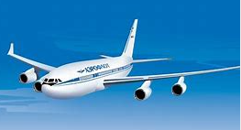

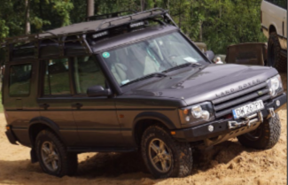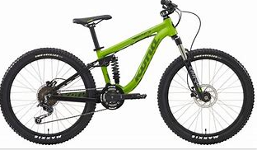

You are going to design a vehicle!
Design Criteria:
- Your vehicle must be a 3D model
- You must be able to put something in it or on it (for example a lego person or a small toy/teddy that will be transported in the vehicle)
- Challenge – Can you include a seat? Can you make a see through window?

My Design!
What will your vehicle look like?
Draw a labelled diagram of your model.

Materials!
List the different materials and equipment you will need to make your model.

Finished Product!
If you can, please attach a photograph here of your finished model (or bring it in to school when we return).
Evaluation!
After you have made your vehicle, think about your finished product.
Was your vehicle able to carry things? ……………………………….
Was it strong and sturdy?.................................................................
What did you like about your vehicle?..............................................
…………………………………………………………………………….
…………………………………………………………………………….
What could you improve? ……………………………………………..
…………………………………………………………………………….
…………………………………………………………………………….
Circle the number of stars out of five that you would give your vehicle.


