Additional Maths Challenges

Interactive/screen games
https://www.topmarks.co.uk/maths-games/mental-maths-train
This game has lots of different options and can be used against a timer to see how many you can get right within a minute!

https://www.topmarks.co.uk/maths-games/hit-the-button
This game is usually very popular with children from EYFS up to Year 2. Children can find different ways of making 10 before the timer runs out!
Lots of different options for number bonds/doubles/halves.

https://mathsframe.co.uk/en/resources/resource/570/Stone-Age-Stu-Addition
‘Stone Age Stu’ – A game to find the missing number in the number sentence. Can be altered by difficulty.

https://www.kirkbycofe.co.uk/page/remote-learning-wb-25.1.21/92259
Link to Class 1 home learning – some ideas for maths at a higher level.
https://www.bbc.co.uk/games/embed/karate-cats-2?exitGameUrl=https%3A%2F%2Fbbc.co.uk%2Fbitesize%2Farticles%2Fzf4sscw
Karate Cats Maths
This game focuses more on word mathematical problems and may need an adult to help read the questions.
Can be quite difficult!

Practical games
Number Thief! - See if your child can write numbers on paper/post it notes from 0 to 20 or up to 30. Can you line them up in the correct order? Choose a toy of your choice to be the ‘number thief’. Child closes their eyes whilst the toy takes a number away – can your child spot the missing number? Great for number ordering/sequencing and language.
- can be done with any numbers (eg. numbers in 2s/5s/10s)

Spot the cars – On your daily walk, take a notepad and see what colour cars you can see. Tick how many red/white/black etc cars you can find. Which did you see the most? Which did you see the least?

Number Bingo – Make your own or use the sheet below. One player is the bingo caller and the others have the number cards. Call out the number sentences/questions and if you have the answer on your card then mark it off with a pen or highlighter.
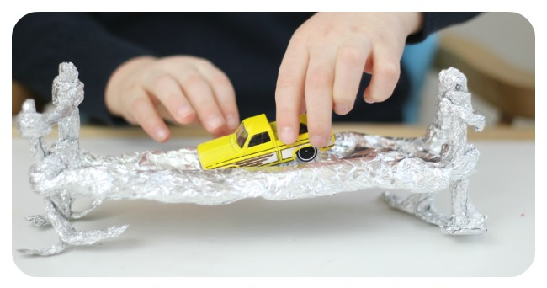
Make it float – You will need tin foil and a small toy car or train of choice. Using only the one material, can you make a boat for the car to float in the sink/bath or bowl of water. Keep trying your boat – does it work? If not, what can you change?

Bingo cards (choose as little or many as you need per game)

10 | 5 | 25
7 | 18 | 21
Player 1

Player 2

9 | 5 | 24
6 | 1 | 30

8 | 12 | 22
17 | 1 | 30
Player 3

Bingo questions (For bingo caller)
(questions can be altered as needed)
- What is double 5?
- What is 1 less than 10?
- What is 10 more than 20?
- What is 20+5?
- What is 26 – 2?
- What is 1 more than 5?
- What is 1 less than 18?
- What is 10+7?
- What is 1 more than 0?
- What is 5+3?
- What is double 11?
- What is 10-2?
- What is 1 more than 20?

