NASA and SpaceX Launch Astronauts to Space!
Did anybody watch or hear about the rocket launch that happened on Saturday 30th May?
On Saturday, The United States opened a new era of human space travel as a private company for the first time launched astronauts into orbit, nearly a decade after the government retired the storied space shuttle program in the aftermath of a national tragedy.
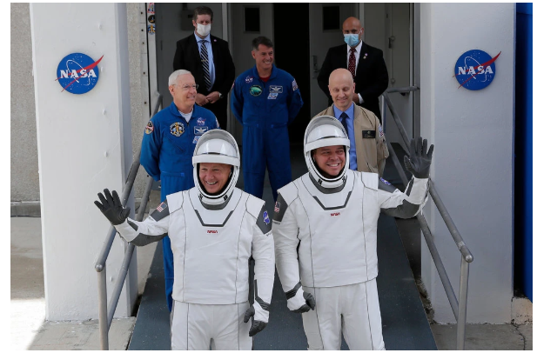
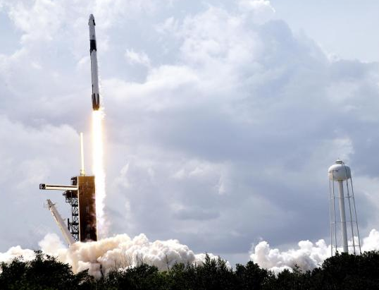
Two American astronauts lifted off at 3:22 p.m. (8.22p.m. our time) from a familiar setting, the same Florida launch pad that once served Apollo missions and the space shuttles. The astronauts are Robert L. Behnken and Douglas G. Hurley, who have been friends and colleagues since both were selected by NASA to be astronauts in 2000.

This week, I would like you to research the historic event that happened on Saturday. I have attached a video and news report if you would like to use these to get you started but feel free to research yourself. I would like you to create a fact-file that tells me all about this event. If you are feeling even more creative you could even design your own rocket and tell me how and why you would design it this way.
https://www.nytimes.com/2020/05/30/science/spacex-launch-nasa.html
If you didn’t get to watch the launch on Saturday here is a video you can watch: https://www.youtube.com/watch?v=zpnCSpoO7n4

