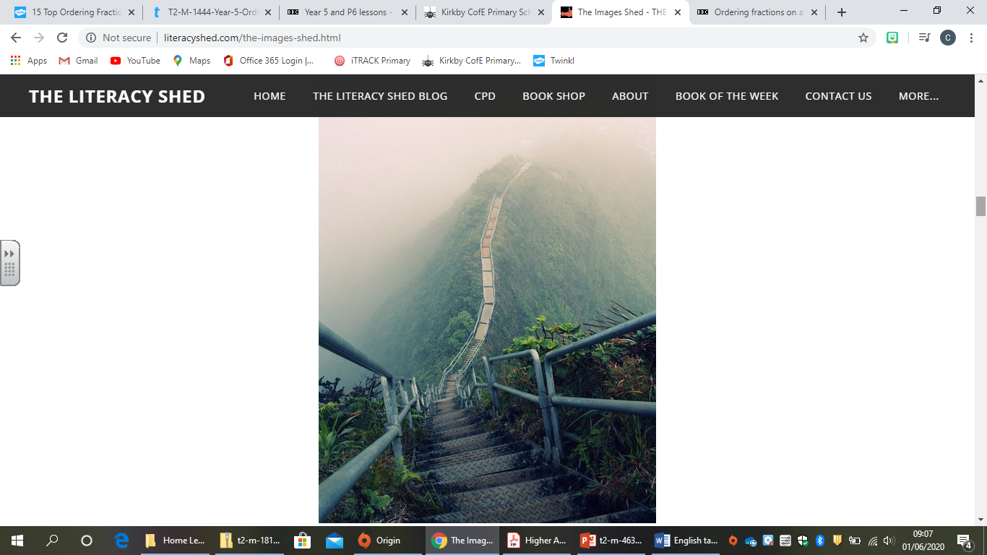
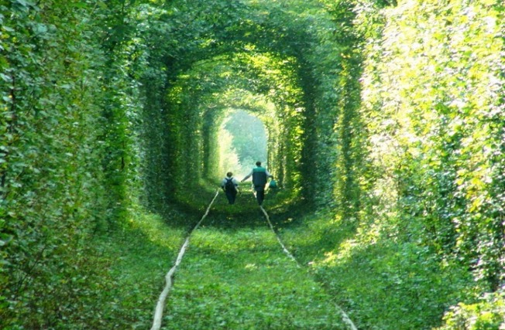
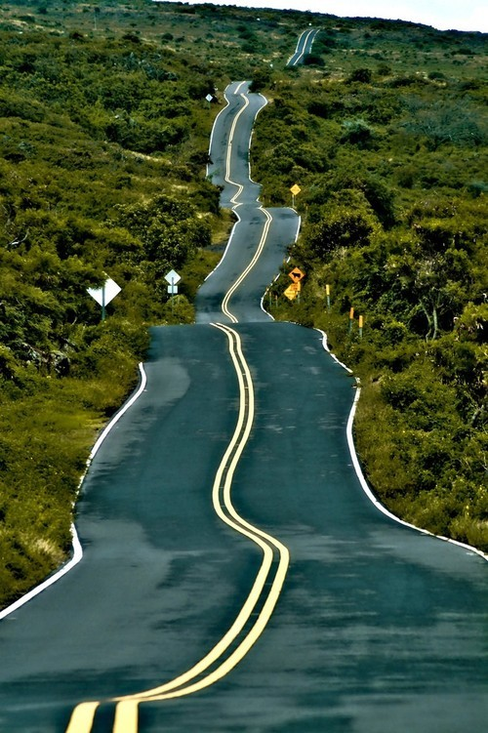
Here are a selection of pictures- choose one picture and use it to create a descriptive piece of writing using skills that you have learnt this year. Use your imagination to write a short story of what you think could happen in the picture.
How would you feel travelling along here alone?
What can you hear?
see?
feel?
What would you be travelling in?
Where is this?

How would your journey end?

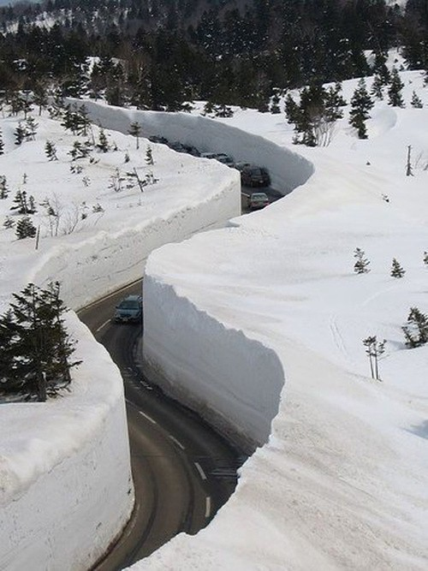
If you would like to send over any of your work or have any questions/ need help then please feel free to email:
dale.mawson@kirkbyce.co.uk
Good luck,
Mr Mawson
Where does this road lead to?

