Henry VIII
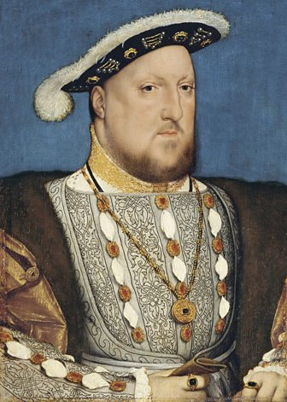

In 1509 Henry VIII became King of England. His father had left him lots of money and he wanted to be the greatest King England ever had.
Henry, was 18 when he became King. He loved music, dancing and playing sports, like jousting and archery.

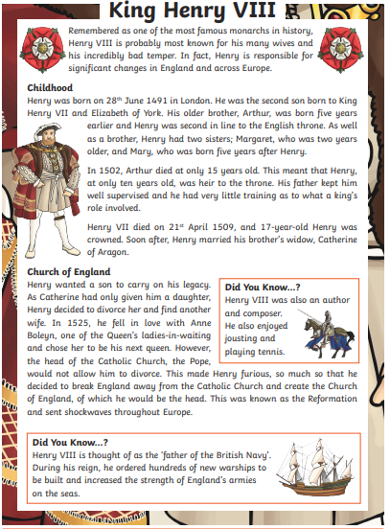
Here is a link to BBC Bitesize, please have a look at the videos and information on here and create a fact file that tells people everything about Henry VIII that they need to know. I have also attached some information sheets below that will also help you.
https://www.bbc.co.uk/bitesize/articles/zdj8wty

