Hello Class 9,
Here is this week’s Maths Challenge to work through at your own pace. Remember, work set is not compulsory and can be completed at your own leisure. The focus this week is area of rectilinear shapes.
Area is the amount of space inside a 2D shape. Below is a quick guide to remind you all how we find the area of a rectilinear shape.
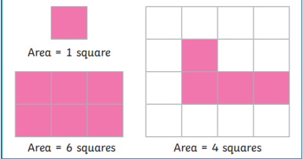
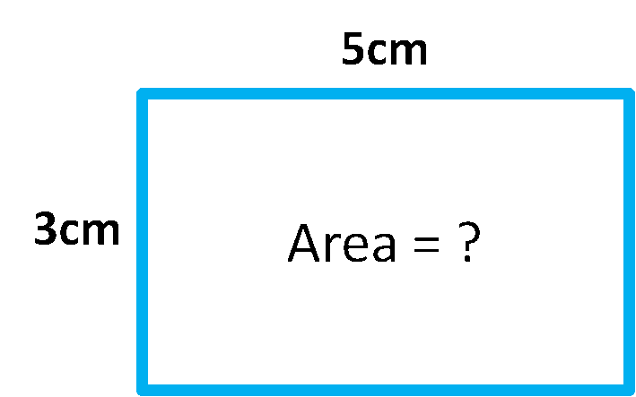
We can count squares to find the area of a rectilinear shape if on a grid.
We can multiply the length of one side with the other
e.g. 5cm x 3cm = 15cm
OR

Have a go at using each method below. You will all be measuring your parent’s carpets in no time
