
Child’s name: ______________________

Goal
When it comes to times tables, speed AND accuracy are important – the more facts your child remembers, the easier it is for them to do harder calculations.
Times Table Rock Stars is a fun and challenging programme designed to help students master the times tables!
To be a Times Table Rock Star you need to answer any multiplication fact up to 12×12 in less than 3 seconds!

Logging in to Times Tables Rock Stars
1
Type play.ttrockstars.com into your browser’s address bar.

2
Click Login! > School > Student

Enter the School Name.
3
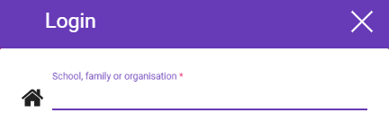

Username: __________________
Password: __________________
4
Enter your child’s username and password.
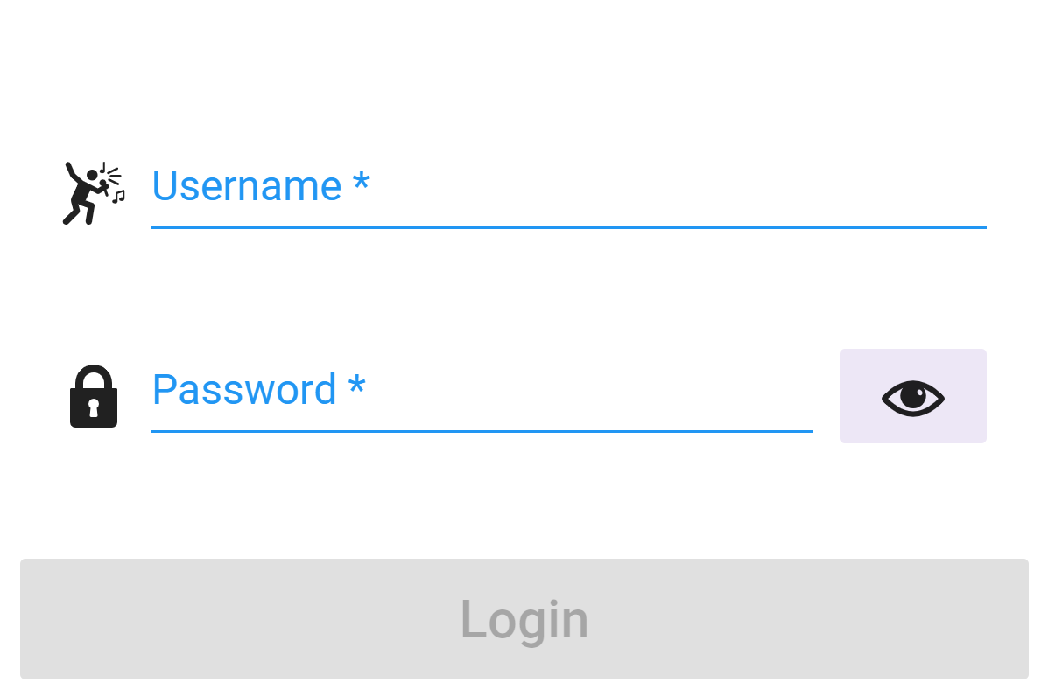

Single Player

Garage - the questions will only come from the times tables the teacher has set for the week. It will include multiplication and division questions.
As pupils start to answer questions, TT Rock Stars works out which facts they take longer on and will give them more of these questions to answer. The Garage is best for getting quicker at a few facts. Players get 10 coins per question.
Studio - the questions in the Studio can be anything from 1×1 up to 12×12.
TT Rock Stars calculates the mean response time from their last 10 games in the Studio and translates that time into a Rock Status.

≤ 1 sec/qu = Rock Hero  ≤ 2 secs/qu = Rock Legend  ≤ 3 secs/qu = Rock Star  ≤ 4 secs = Headliner  ≤ 5 secs/qu = Support Act  ≤ 6 secs/qu = Breakthrough Artist | ≤ 7 secs/qu = Unsigned Act  ≤ 8 secs/qu = Gigger  ≤ 9 secs/qu = Busker  ≤ 10 secs/qu = Garage Rocker  > 10 secs/qu = Wannabe
If you don’t play in the Studio you don’t get a Rock Status.
Players earn 1 coin per question and the Studio is the place for them to set their best time across all the tables.
Soundcheck – When you play Soundcheck, you get 20 questions each with a 5-second time limit. The questions are multiplication only and evenly weighted in terms of difficulty each time you play. Players earn 5 coins per correct answer.
Multiplayer
Rock Arena - The Arena allows players to compete against all other members of their Band (their Bandmates would need to join the same game in order to compete together).
A new Arena game starts every 15 seconds and once the clock starts they race to answer more questions than the others. In the Arena, questions will only come from the times tables the teacher has set for the week, similar to the Garage. They earn 1 coin per correct answer.
Rock Festival - The Rock Festival games are open to players from around the world. Like the Arena, there is no limit to the number of players who can join a game; however, unlike the Arena, questions are selected at random from 1×1 to 12×12.
Pupils might choose the Rock Festival if they were playing at home (and therefore couldn't easily synchronise playing against a classmate) or wanted to compete against others not in their Band. They earn 1 coin per correct answer.
Game Modes

If you click on your avatar icon in the top right of the screen and then click My Stats, a heatmap like the one below will load. It shows how successful your child is at each of the facts.

Stats

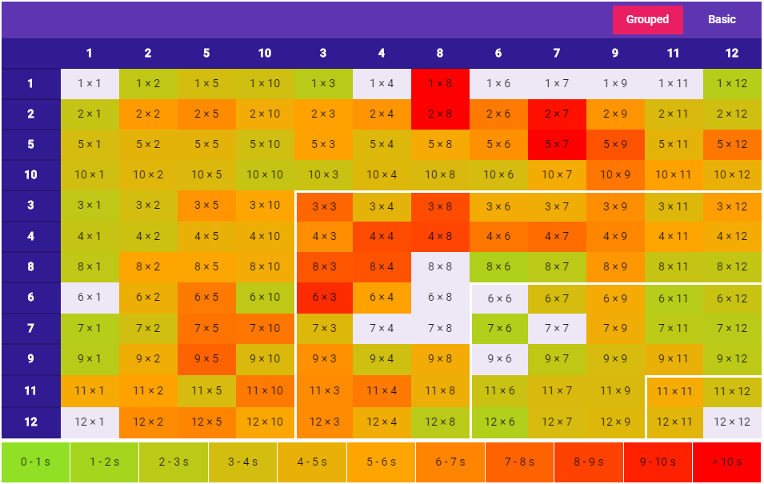

Contact your child’s teacher if…
- You have username or password issues
- Something isn’t working or you’re not sure how it works
- You have a complaint or a suggestion
- You have something nice to say about ttrockstars.com!

