Positive Behaviour Policy



“Building on a tradition of achievement and values in a caring environment”

Written: December 2025
Date of Review: December 2026

Kirkby CE Primary School
Positive Behaviour Policy.

This is Kirkby CE Primary School’s policy for behaviour and discipline and is set within the context of the whole school aims, mission statement and Christian ethos.
“Do not look out only for your own interests, but take an interest in others too”.

In school, we strive to develop the whole person by providing a caring ethos where everyone feels safe, confident, valued and respected. We believe that each person is an individual with a God given dignity. All of our children are entitled to be given opportunities to reach their full potential. Therefore we must provide for them an education which will enable them to be personally fulfilled and work together in a supportive way that enables all to reach their full potential, emotionally, socially and academically.

"Good behaviour is a necessary condition for effective teaching to take place."
(Education Observed 5 - DES 1987)

The Governing Body accepts this principle and seeks to create an environment in the school, which encourages and reinforces good behaviour. It is the governing body, head teacher and senior leadership team’s responsibility to promote good behavior and support colleagues to implement this policy. At Kirkby CE we want to encourage an atmosphere and environment where the children feel safe and secure. This can be achieved when the children are enthusiastic, vibrant, happy, thoughtful and respect other people and their property

Policy Aims:
The primary aim of our behaviour policy is to promote good behaviour. We have school rules and the staff do not ignore unacceptable behaviour. This policy also aims:
- To create an environment which encourages and reinforces good behaviour.
- To ensure that children follow Gospel and British values
- To define acceptable standards of behaviour.
- To encourage consistency of response to both positive and negative behaviour.
- To promote self-esteem, self-discipline, respect and positive relationships.

STANDARDS OF BEHAVIOUR
In seeking to define acceptable standards of behaviour, we acknowledge that these are goals to be worked towards. The school has a central role in the children's social and moral development just as it does in their academic development. Just as we measure academic achievement in terms of progress and development over time towards academic goals, so we measure standards of behaviour in terms of the children's developing ability to conform to our behavioural goals.

We define unacceptable behaviour as:
- Disruption in lessons, in corridors between lessons, and at break and lunchtimes
- Non-completion of classwork
- Poor attitude
- Refusing to follow direct instructions
- Lack of respect
- Repeated breaches of the school rules
- Any form of bullying
- Physical assault
- Vandalism
- Theft
- Fighting
- Racist, sexist, homophobic or discriminatory behaviour
- Peer on Peer Abuse (see Appendix 1)
- Possession of any prohibited items.

The following roles and responsibilities will be implemented in support of the positive behaviour policy:
The Governing Body will:
- Support with the implementation of the policy
- Provide advice to the head teacher regarding disciplinary issues and exclusions
- Review the effectiveness of the policy
- Understand that behaviour is a management issue

The Head teacher & SLT will:
- Implement the positive behaviour policy, reinforcing the need for consistency throughout the school.
- Report to governors regarding the effectiveness of the policy
- Meet with parents/carers of challenging children
- Support staff when dealing with challenging behaviour and the law
- Ensure the health and safety and welfare of all children
- Praise and encourage positive behaviour with rewards and dedicated assemblies
- Ensure the school environment encourages positive behaviour
- Ensure that staff deal effectively with poor behaviour, and will monitor how staff implement this policy to ensure rewards and sanctions are applied consistently.

Staff will:
- Model positive behaviour
- Offer the children choices and the chance to make the right decision
- Provide a personalised approach to the specific behavioural needs of particular pupils
- Record behaviour incidents (on CPOMS – Stage 2)
- Create a positive climate with realistic expectations
- Emphasise the importance of being valued as an individual within the group
- Promote, through example, honesty and courtesy
- Provide a caring and effective learning environment
- Encourage relationships based on kindness, respect and understanding of the needs of others
- Ensure fair treatment for all regardless of age, gender, race, ability and disability;
- Show appreciation of the efforts and contribution of all
- Manage the appropriate use of different rewards effectively.
- Inform parents/carers about the welfare and behaviour of their children
The senior leadership team will support staff in responding to behaviour incidents including seeking training and support when necessary.
Parents
Parents are expected to:
- Reinforce the school’s Learners code
- Support their child in adhering to the school rules and systems
- Inform the school of any changes in circumstances that may affect their child’s behaviour
- Discuss any behavioural concerns with the class teacher promptly
- Avoid commenting on school issues on social media.

The Children will:
- Follow the school rules and Learners Code
- Behave in an orderly and self-controlled way
- Be responsible for own actions and their impact on others in the classroom and around the school
- Show respect to members of staff and each other, their work and property
- Move quietly around the school
- Treat the school buildings and school property with respect
- Accept sanctions when given
- Refrain from behaving in a way that brings the school into disrepute, including when outside school
- Always set a good example
- Always remember manners.
- Be kind to each other including, kind hands, kind feet and kind words.
- Be respectful to everyone
- Use social media responsibly out of school.
- Treat others, as you would like them to treat you.
- Be ambassadors for Kirkby CE Primary School both in and outside of the school gates.

Lunchtime & Playtime
Playtime is treated the same as any other time of the day and the same rules apply. On both playgrounds, football can only be played within the football pitch on a rota basis. On the KS2 yard this is the same with the basketball. Any inappropriate behaviour on the pitch will result in loss of pitch time up to 2 weeks. There are quiet areas for those children who wish to read or draw etc.
The teaching assistants and staff on duty will promote good behaviour/game playing. They will follow the school behavior policy and record any incidents on CPOMS.

Pupils conduct outside the school gates
At Kirkby CE Primary School we have high expectations of the children’s behaviour and would expect the children to behave appropriately on their way to and from school, and when wearing the school uniform. We would also expect them to behave appropriately when they are engaged in extra-curricular clubs and extended school activities which take place beyond the normal school day – e.g.: football matches. Incidents outside school that affect school will be investigated and sanctions applied.
Attendance on school trips and residentials are deemed to be a privilege and therefore any child who cannot display appropriate behavior at all times will not be accepted onto the school trip.

Any poor behaviour outside of school, which can be associated with our children or our school will follow the sanctions as outlined in this policy. School is proud of the reputation of our school and will always strive to ensure that our children show good standards of conduct at all times.

REWARDS
Our emphasis is on rewards to reinforce good behaviour. We believe that rewards have a motivational role helping children to see that good behaviour is valued.
The most common reward is praise, informal and formal, public and private, to individuals and groups. It is earned by the maintenance of good standards as well as by particularly noteworthy achievements.
Classes use praise, stickers and Team Points to acknowledge good behaviour.

Whole school rewards
Team Points are to be used for good work and/or effort in books, teachers and TAs should write the number to show the child has been given the reward.

3 for excellent work/effort 2 for very good work/effort 1 for work/effort above the average
- After 50 Team Points the child gets a bronze certificate
- After 75 Team Points the child gets a silver certificate
- After 100 Team Points the child gets a gold award
All children have a 100 square and tick off the Team Points when they are awarded them.

Team Points should be used for positive attitude to work, good manners, involvement in lessons, and any other positive behaviours including playtime and lunchtime. These are added to the child’s 100 square as well.
Each class will have Team Points Houses, all individual Team Points will feed into the week’s group score. The Houses will be named after forests in the United Kingdom: Galloway (Scotland), Kielder (England), Wentwood (Wales) and Carrigan (Northern Ireland).
All classrooms will have the houses displayed and the names of the children in them – the children will add their team points to this display. These totals will be collected in on Friday morning by Year 6 children.
The House with the most Team Points will be allocated 4 points to go towards the whole school winners. This will descend to the lowest team being awarded 1 point towards the whole school winner. The team with the most points across the school will be recorded on a chart in assembly. Each half term the House winners will be rewarded with an extra playtime.
The following rewards are presented on a Friday in class:-
- Reader of the Week – a postcard to take home with explanation of the reason
- Writer of the Week – a Kirkby CE ‘signed’ pencil
- Jigsaw (PSHE) Award – a certificate to take home with explanation of the reason
In the ‘Achievement Assembly’ (on Friday afternoon) children are awarded the Star of the Week Certificate. The class teacher from each class reading out the reason in front of the whole school.

STEPS & SANCTIONS
Alongside positive reinforcement for appropriate behaviour, all teachers use a staged approach to help manage classroom behaviour. This is a whole school approach for behaviour management with agreed whole school sanctions. This is backed up by clear and consistent explanations about why certain behaviour is inappropriate.
The principle behind this system is:
1. That all pupils have the opportunity to make positive choices about their behaviour and influence outcomes.
2. That teachers integrate a system within daily teaching in order to promote positive behaviour and effective behaviour management skills.
3. Pupils who regularly follow the rules are noticed and rewarded.
4. The system allows for the following:
- A consistent approach that can be used by all staff
- Whole class and individual reward system
- Teaching of specific behaviours and routines

Children start each day not on stage; each day is treated a fresh start. If behaviour slips to include low level disruption they will become stage 1. The child will be warned about possible consequences and an appropriate sanction applied. If the child’s behaviour continues or deemed serious enough they move to stage 2 of the policy and appropriate sanctions applied. If poor behaviour continues the child will move to stage 3 or 4 if necessary and appropriate sanctions applied.
Please note: Certain harmful and abusive behaviour goes immediately beyond the stages and is dealt with by SLT immediately.

Stage 1
Low level disruption
e.g. Talking, not listening, out of seat, making inappropriate noises, not working, pushing,
rough non malicious play.
ACTION:
Minimal low key response managed by the Class teacher:
Praise of other children - eye contact (stern stare, raised eye brow)
Assertive body language (crossed arms, frowns etc.)
Name/pause technique - being close and whispering a firm reminder
Reminder of class rules
A quiet word
Direct to seat
Quiet unobtrusive ‘What should you be doing?’ or ‘Are you okay?’
Not allowing them to sit with friends
Have a lining up order for assemblies/playtimes

Stage 2
e.g. Continued low level disruption, not completing a reasonable amount of work in a set time due to behaviour, deliberate disruption e.g. trying to distract other pupils from their work, repeated rough play or general roughness, etc. / lying etc.
ACTION:
Response managed by class teacher:
Seat somewhere separate from class group
Set a time limit for improved behaviour
Reminder of expected behaviour
Move to end of row if in assembly, large class group
Complete loss of playtime child will reflect on their behaviour and complete appropriate activity eg. -completing work or behaviour reflection.
(Any child who is staying in will be supervised by SLT on duty at lunch time)
(Mon – DT Tues – SW Wed –JD Thurs – LE Fri – DM)
Access ‘Time out’ child sent to a named class until they are ready to join back in.
Member of school staff or a sensible child to take child to phase leader for an
appropriate length of time
Child to apologise.
Informal conversation with parent/carer or letter 1 sent home to parents

.

Stage 3
e.g. Intentional violence / intentional damage to property / refusal or lack of respect / persistent rudeness / bullying etc.

ACTION:
Response usually managed by senior leaders
Fixed term loss of breaktime and lunchtime
Escorted to (or send for) DHT or HT in that order
Possible playtime/lunchtime exclusion
Possible SENDCO involvement for referral or support
Record in racist incidents book if and when necessary
Letter of apology by the child
Pastoral support programme
Letter 2 sent home
Meeting with parents (DHT/HT). Inform SENDCO if appropriate
HT/DHT/Mentor can put a pupil ‘on an individual behaviour plan whenever is deemed appropriate
and invite parents in to discuss and agree.
Letter 3 sent home

.

Stage 3
e.g. Intentional violence / intentional damage to property / refusal or lack of respect / persistent rudeness / bullying etc.
ACTION:
Response usually managed by senior leaders
Fixed term loss of breaktime and lunchtime
Escorted to (or send for) Phase Leader, DHT or HT in that order
Possible playtime/lunchtime exclusion
Possible SENDCo involvement for referral or support
Record in racist incidents book if and when necessary
Letter of apology by the child
Pastoral support programme
Letter 2 sent home
Meeting with parents (DHT/HT). Inform SENCo if appropriate
HT/DHT/AHT can put a pupil ‘on conduct card / reward chart/individual behaviour contract /plan whenever is deemed appropriate(Appendix 4-6) and invite parents in to discuss and agree.
Letter 3 sent home

.

Where anti-social, disruptive or aggressive behaviour is frequent, sanctions alone are ineffective.

Stage 4
Repeatedly leaving class without permission or running around school / behaviour is creating a health and safety risk/ running out of school / repeated fighting and intentional physical harm to other children / verbal abuse to any staff / theft, /persistent bullying

ACTION:
Taken to DHT/HT immediately
Meeting with parents
Internal exclusion at very least
Lunchtime/playtime exclusion
Possible fixed term exclusion
Possible permanent exclusion
Possible withdrawal from next trip/event
Pastoral support programme
Involvement of other agencies as deemed necessary

.

In such cases careful evaluation of the curriculum on offer, classroom organisation and management, and whole school procedures should take place to eliminate these as contributory factors.
Additional specialist help and advice from the educational psychologist may be necessary. This decision will be made by the head teacher.

Communication and parental partnership
We give high priority to clear communication within the school and to a positive partnership with parents since these are crucial in promoting and maintaining high standards of behaviour.
We expect all of our children to follow our behaviour standards and conduct themselves appropriately. In the instance that an incident of poor behaviour takes place it will be investigated by school staff and appropriate actions taken. If deemed serious enough or there is concern with a child it should be reported to DHT who will agree appropriate actions. If necessary DHT will contact parents during the school day.
Where the behaviour of a child is giving cause for concern, it is important that all those working with the child in school are aware of those concerns and of the steps which are being taken in response. The key professional in this process of communication is the class teacher who has the initial responsibility for the child's welfare. Early warning of concerns should be communicated to senior staff (DHT & HT) so that strategies can be discussed and agreed before more formal steps are required.
A positive partnership with parents is crucial to building trust and developing a common approach to behaviour expectations and strategies for dealing with problems. Parental participation in many aspects of school life is encouraged. This participation assists the development of positive relationships in which parents are more likely to be responsive if the school requires their support in dealing with difficult issues of unacceptable behaviour.

SEN code of practice
Children with serious or repeated behaviour difficulties may need to have an individual behaviour plan in accordance with the Special Needs Code of Practice. Special Needs are seen as a reason not an excuse for inappropriate behaviour, and in working with parents/carers our role is to teach appropriate behaviours.
SEN Considerations

The SEN Code of practice identifies that:
‘Persistent disruptive or withdrawn behaviours do not necessarily mean that a child or young person has SEN. Where there are concerns, there should be an assessment to determine whether there are any causal factors such as undiagnosed learning difficulties, difficulties with communication or mental health issues.’ (6.21)

At Kirkby CE we recognise that certain behaviours can be due to an unidentified need. In school we follow the graduated approach and if needed we will monitor patterns in behaviour and address concerns. We will put support in place and/or refer to appropriate services.
ADAPTIONS

Whilst we have a universal expectation of behaviour, school staff will consider age, stage and additional needs when actioning rewards and sanctions. Extenuating circumstances in a child’s life will also be considered. Those children with an individual behaviour plan may have behaviour targets they are working towards.

Pupil support

The school recognises its legal duty under the Equality Act 2010 to prevent pupils with a protected characteristic from being at a disadvantage. Consequently, our approach to challenging behaviour may be differentiated to cater to the needs of the pupil.
Where necessary, support and advice will also be sought from specialist teachers, an educational psychologist, medical practitioners and/or others, to identify or support specific needs
When acute needs are identified in a pupil, we will liaise with external agencies and plan support programmes for that child. We will work with parents to create the plan and review it on a regular basis. This plan may include transfer to a more appropriate placement.

Pupil transition
To ensure a smooth transition to the next year, pupils have transition sessions with their new teacher(s). In addition, staff members hold transition meetings – these take place in July.
To ensure behaviour is continually monitored and the right support is in place, information related to pupil behaviour issues may be transferred to relevant staff at the start of the term or year. Information on behaviour issues may also be shared with new settings for those pupils transferring to other schools.
CPOMS ensures all necessary information is transferred to relevant staff and schools securely.

Monitoring arrangements
This behaviour policy will be reviewed annually by the Head teacher and ratified by the full governing body.

Letters to parents about pupil behaviour – templates

First behaviour letter – when child reaches Stage 2

Dear parent,
Recently, your child, _____________________________, has not been behaving as well in school as they could.
It is important that your child understands the need to follow our pupil code of conduct, and I would appreciate it if you could discuss their behaviour with them.
If your child’s behaviour does not improve, I will contact you again and suggest that we meet to discuss how we can work together. However, at this stage I am confident that a reminder of how to behave appropriately will be sufficient.
Yours sincerely,

Class teacher name: _____________________________________________________________________

Class teacher signature: ____________________________________Date:__________________

--------------------------------------------------------------------------------------------------------------------------------

Behaviour letter – return slip

Please return this slip to school to confirm you have received this letter. Thank you.

Name of child: __________________________________________________________________________

Parent name: ___________________________________________________________________________

Parent signature: _________________________________________________Date: _________

Second behaviour letter – when child’s behaviour does not improve at all and/or reaches Stage 3

Dear parent,
Following my previous letter regarding the behaviour of ________________________, I am sorry to say that they are still struggling to adhere to our pupil code of conduct.
I would appreciate it if you could arrange to meet me after school so we can discuss a way forward.
Yours sincerely,

Class teacher name: _____________________________________________________________________

Class teacher signature: __________________________________Date: ________________

Behaviour letter – return slip

Please return this slip to school to confirm you have received this letter. Thank you.

Name of child: __________________________________________________________________________

Parent name: ___________________________________________________________________________

Parent signature: _________________________________________________Date: _________

Third behaviour letter – sent home after Conduct Card, Reward Chart etc have not worked and behaviour is still unacceptable

Dear parent,
I am sorry to report that, despite meeting and creating a behaviour contract, _______________________, has continued to misbehave.
_________________________ would now benefit from a structured approach to help improve their behaviour in school.
I would be grateful if you could attend a meeting with the head teacher, the special educational needs co-ordinator and myself, to discuss how we can best support your child in improving their behaviour.
Insert details of the meeting time, date and location, as necessary, or how to contact the school to arrange the meeting.

Yours sincerely,

Class teacher name: _____________________________________________________________________

Class teacher signature: ______________________________________Date: _____________

Behaviour letter – return slip

Please return this slip to school to confirm you have received this letter. Thank you.

Name of child: __________________________________________________________________________

Parent name: ___________________________________________________________________________
Parent signature: _________________________________________________Date: _________

Behaviour Reflections
Reflection sheet 
Date

What I did.

Who was involved
What I was thinking and feeling at the time

Who has my behaviour affected?
Name class


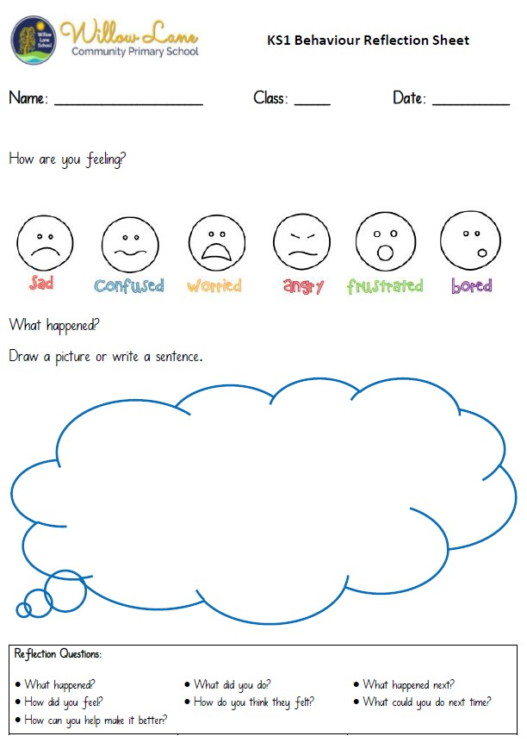
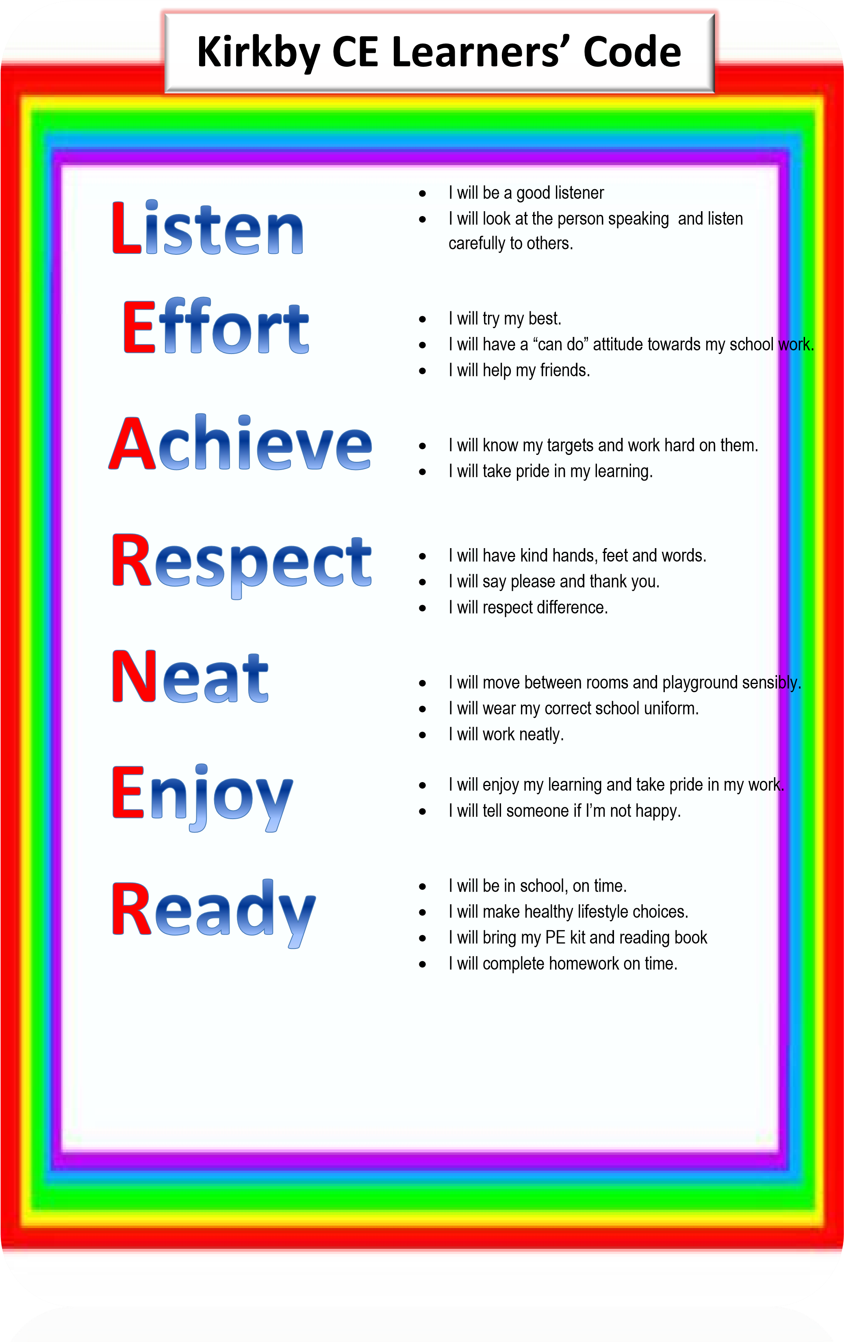

Appendix 1
PEER ON PEER ABUSE – All staff should be clear as to the school policy and procedures with regards to peer on peer abuse.

Para. 48 – All staff should be aware that safeguarding issues can manifest themselves via peers on peer abuse.
This is most likely to include but is not limited to:
• Bullying (including cyber bullying)
• Physical abuse such as hitting, kicking, shaking, biting, hair pulling, or otherwise causing physical harm.
• Sexual violence and sexual harassment;
• Sexting (also known as youth produced sexual imagery); and
• Initiation/hazing type violence and rituals
Keeping Children Safe in Education, September 2018

Peer on peer abuse is abuse and will never be tolerated or passed off as ‘banter’, ‘just having a laugh’ or ‘part of growing up’. All allegations of peer on peer abuse will be recorded as a child welfare concern and will be dealt with in line with the school behaviour policy and antibullying policy.

