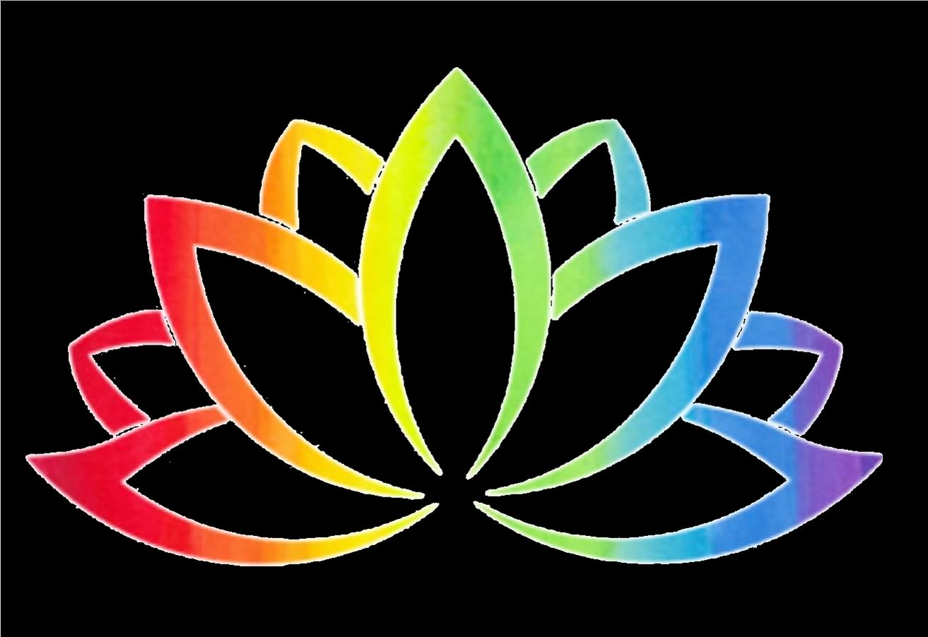

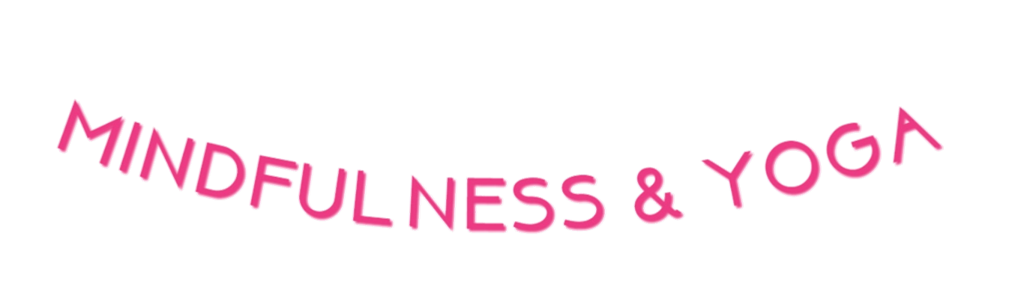












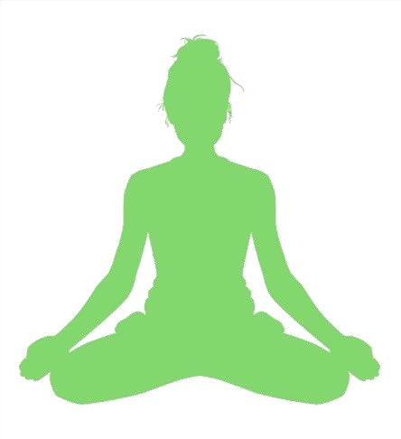

‘Little Sunshine’ Mindfulness Pack

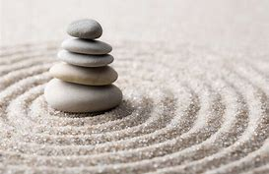

Timetable
Create a timetable for your day with exercise time, meditation, yoga, school time, mealtime, playtime, activity time and reading time.
Things we can do
Go into the garden
Practice yoga
Practice meditation
Do something you enjoy
Listen to calming music
Read
Meditate
Chat
Keep a journal
Draw
At the end of the day write down what has been the best part of your day
Mindful colouring

Mindfulness games
What can I feel?
Put a range of items into a bag. Blindfold one person and ask them to remove the items from the bag and describe how it feels, sounds, smells. The person then must guess what the item is.
Sensory game
Find the following items:
3 smooth items
2 rough items
3 soft items
2 hard items
3 sounds
1 smell
3 red items
4 blue items
2 green items
Gloop
Mix the ratio one cup of cold water with two cups of cornflour. Use the hands to mix together. There you have some gloop.

Shaving foam activity
Spray some shaving foam onto a tray. Use your fingers to write, draw, make shapes and patterns.
Memory game
Place a range of items onto a tray. Hide your eyes while one person takes an item or two off the tray. The rest of the group must remember what items are missing.
Gratitude jars
Decorate a jar with stickers, felt tips and ribbon. Each day pop a message in the cup for each family member to say thank you. For example ‘Thank you Mum for giving me a hug’, ‘Thank you brother for helping me do my homework’.
Affirmation bracelet
Cut a long, thin piece of paper. Write your own affirmations onto the bracelet
e.g. ‘I am strong’, ‘I am unique’, ‘I am beautiful’
Place the bracelet around the wrist and celotape together.
Alphabet activity
Write the alphabet down the left hand side of the paper. For each letter write a positive word to describe yourself. For example
I am amazing
I am brave
I am courageous
Playdough activity
Place playdough in the hand. Squeeze, squash, pat, poke, roll and flatten the playdough. Take your time to focus on each. Make your name, shapes and numbers with your playdough.
Compliment activity
Write down all the great things about your family. Share with each other.
Clap game
Make a rhythm of sound using clapping and tapping. The person next to you copies.
Mindful colouring
Colour in while listening to calming music. If you don’t have a colouring book draw swirls on your paper and colour in the gaps.
Nature painting
Collect some pebbles, twigs and stones to colour or paint. You can create your own colourful garden or paint affirmations on your stones for example ‘Love’, ‘Be happy’, ‘Be kind’.

Breathing techniques
Belly breathing
Lie down on the bed with your hands on your belly. As you slowly breathe in the belly rises, as you slowly breathe out the belly falls. This relaxes the body and mind.
Head movement breathing
As we breathe in look up, as we breathe out lower the head, as we breathe in look to the right, as we breathe out look to the left. Continue this focusing on the breath.
Finger breathing
As we breathe in we move the left finger up the right thumb, as we breathe out we move the finger down the thumb. We continue to do this up and down each finger, slowly breathing in and out through the nose, concentrating on the breath.

Meditation
Meditation is when we focus our mind onto either a sound, music, the breath, someone’s voice or a visualisation. When we do this, we calm the monkey mind. This allows us to feel calm and relaxed.
You can meditate any time of day but it is a good way to start your day feeling positive or helps with sleep at the end of the day.
Here is a relaxation meditation.
Read the meditation slowly and calmly. Play some calming music.

Lie on the bed or a mat with the eyes closed. Relax the body.
Focus on the feet and toes, relax the feet and toes, if there is any tension let it go and relax
Focus on the legs and the knees, relax the legs and knees, if there is any tension let it go and relax
Focus on the stomach and hips, relax the stomach and hips, if there is any tension let it go and relax
Focus on the shoulders, relax the shoulders, if there is any tension let it go and relax
Focus on the arms, relax the arms, if there is any tension let it go and relax
Focus on the hands and fingers, relax the hands and fingers, if there is any tension let it go and relax
Focus on the face, relax the eyes, cheeks, chin and jaw, if there is any tension let it go and relax
Focus on the whole body, relax the whole body, if there is any tension let it go and completely relax.
Feel as if your body is melting into the bed. Relax the whole body.
When you are ready wiggle your fingers and toes and slowly open the eyes.

Peer massage
Sit in a line with your family. Relax the body. Play some calming music.
Use your fingers to draw swirls, stripes, lines, zig zags, spots, waves, circles, triangles, squares, rectangles, stars, diamonds, the alphabet and numbers.

littlesunshineyoga@outlook.com
Twitter @liverpoolshine

