
Kirkby C of E Primary School
Building on a tradition of achievement and values in a caring environment
PSHE
Planning Overview 2025-26

 | Autumn 1 | Autumn 2 | Spring 1 | Spring 2 | Summer 1 | Summer 2
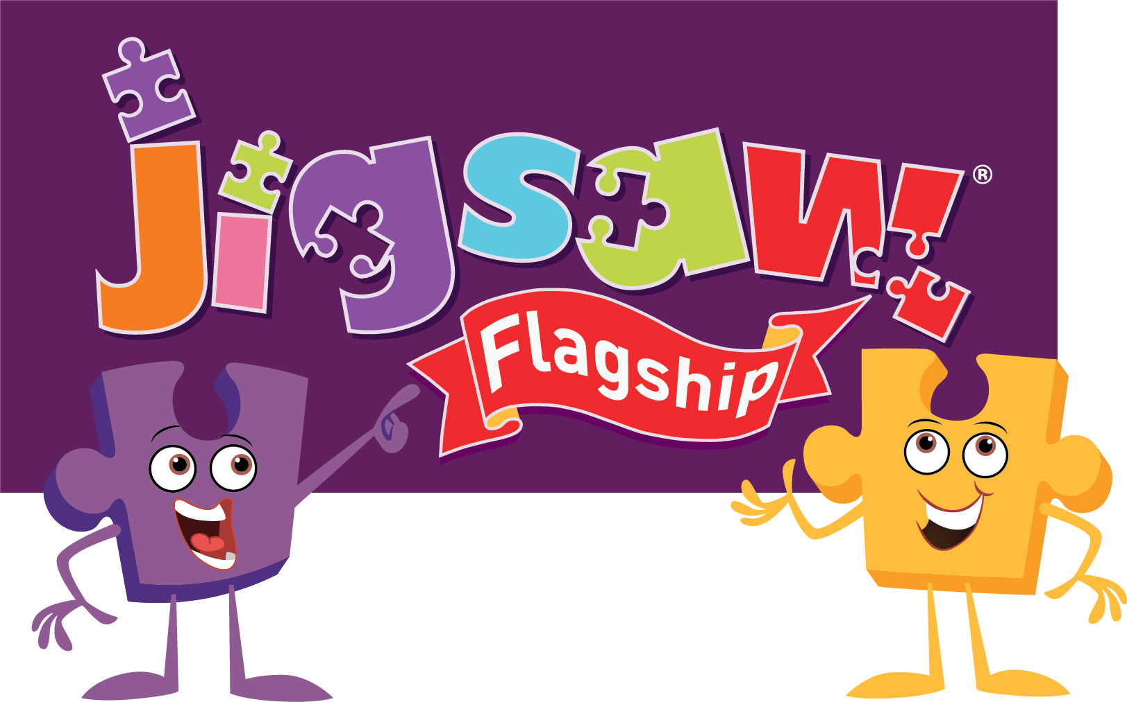 | Being Me In My World | Celebrating Difference | Dreams and Goals | Healthy Me | Relationships | Changing Me
Nursery & Reception  Ages 3-5 | Self-identity Understanding feelings  Being in a classroom Being gentle  Rights and responsibilities | Identifying talents Being special  Families  Where we live  Making friends Standing up for yourself | Challenges Perseverance  Goal-setting  Overcoming obstacles Seeking help  Jobs Achieving goals | Exercising bodies Physical activity Healthy food  Sleep  Keeping clean  Safety | Family life Friendships  Breaking friendships Falling out  Dealing with bullying Being a good friend | Bodies  Respecting my body Growing up  Growth and change  Fun and fears Celebrations
Year 1  Ages 5-6 | Feeling special and safe  Being part of a class Rights and responsibilities Rewards and feeling proud  Consequences  Owning the Learning Charter | Similarities and differences Understanding bullying and knowing how to deal with it Making new friends Celebrating the differences in everyone | Setting goals Identifying successes and achievements Learning styles Working well and celebrating achievement with a partner  Tackling new challenges  Identifying and overcoming obstacles Feelings of success | Keeping myself healthy  Healthier lifestyle choices  Keeping clean Being safe  Medicine safety/safety with household items  Road safety  Linking health and happiness | Belonging to a family Making friends/being a good friend  Physical contact preferences  People who help us Qualities as a friend and person  Self-acknowledgement Being a good friend to myself  Celebrating special relationships | Life cycles – animal and human  Changes in me  Changes since being a baby Differences between female and male bodies (correct terminology)  Linking growing and learning Coping with change  Transition
Year 2  Ages 6-7 | Hopes and fears for the year  Rights and responsibilities Rewards and consequences  Safe and fair learning environment  Valuing contributions Choices  Recognising feelings | Assumptions and stereotypes about gender  Understanding bullying  Standing up for self and others  Making new friends Gender diversity Celebrating difference and remaining friends | Achieving realistic goals  Perseverance  Learning strengths  Learning with others Group co-operation Contributing to and sharing success | Motivation Healthier choices  Relaxation  Healthy eating and nutrition  Healthier snacks and sharing food | Different types of family  Physical contact boundaries  Friendship and conflict Secrets  Trust and appreciation Expressing appreciation for special relationships | Life cycles in nature Growing from young to old  Increasing independence Differences in female and male bodies (correct terminology) Assertiveness Preparing for transition
Year 3  Ages 7-8 | Setting personal goals Self-identity and worth Positivity in challenges  Rules, rights and responsibilities Rewards and consequences Responsible choices  Seeing things from others’ perspectives | Families and their differences  Family conflict and how to manage it (child-centred)  Witnessing bullying and how to solve it Recognising how words can be hurtful  Giving and receiving compliments | Difficult challenges and achieving success Dreams and ambitions New challenges  Motivation and enthusiasm  Recognising and trying to overcome obstacles Evaluating learning processes Managing feelings  Simple budgeting | Exercise Fitness challenges  Food labelling and healthy swaps Attitudes towards drugs  Keeping safe and why it’s important online and off line scenarios Respect for myself and others  Healthy and safe choices | Family roles and responsibilities Friendship and negotiation  Keeping safe online and who to go to for help  Being a global citizen Being aware of how my choices affect others  Awareness of how other children have different lives  Expressing appreciation for family and friends | How babies grow Understanding a baby’s needs  Outside body changes Inside body changes  Family stereotypes Challenging my ideas Preparing for transition
Year 4  Ages 8-9 | Being part of a class team Being a school citizen Rights, responsibilities and democracy (school council) Rewards and consequences Group decision-making Having a voice  What motivates behaviour | Challenging assumptions Judging by appearance Accepting self and others Understanding influences Understanding bullying Problem-solving Identifying how special and unique everyone is  First impressions | Hopes and dreams Overcoming disappointment Creating new, realistic dreams Achieving goals Working in a group  Celebrating contributions Resilience Positive attitudes | Healthier friendships Group dynamics Smoking Alcohol Assertiveness  Peer pressure Celebrating inner strength | Jealousy Love and loss Memories of loved ones Getting on and Falling Out Girlfriends and boyfriends Showing appreciation to people and animals | Being unique  Having a baby  Girls and puberty Confidence in change Accepting change Preparing for transition Environmental change
Year 5  Ages 9-10 | Planning the forthcoming year Being a citizen  Rights and responsibilities Rewards and consequences  How behaviour affects groups Democracy, having a voice, participating | Cultural differences and how they can cause conflict Racism Rumours and name-calling  Types of bullying  Material wealth and happiness  Enjoying and respecting other cultures | Future dreams  The importance of money  Jobs and careers Dream job and how to get there  Goals in different cultures Supporting others (charity) Motivation | Smoking, including vaping Alcohol  Alcohol and anti-social behaviour Emergency aid  Body image Relationships with food  Healthy choices Motivation and behaviour | Self-recognition and self-worth  Building self-esteem Safer online communities  Rights and responsibilities online Online gaming and gambling  Reducing screen time  Dangers of online grooming  SMARRT internet safety rules | Self- and body image  Influence of online and media on body image  Puberty for girls Puberty for boys  Conception (including IVF)  Growing responsibility Coping with change Preparing for transition
Year 6 Ages 10-11 | Identifying goals for the year  Global citizenship Children’s universal rights  Feeling welcome and valued  Choices, consequences and rewards  Group dynamics Democracy, having a voice  Anti-social behaviour Role-modelling | Perceptions of normality Understanding disability  Power struggles Understanding bullying Inclusion/exclusion Differences as conflict, difference as celebration Empathy | Personal learning goals, in and out of school  Success criteria  Emotions in success  Making a difference in the world Motivation Recognising achievements Compliments | Taking personal responsibility  How substances affect the body Exploitation, including ‘county lines’ and gang culture  Emotional and mental health Managing stress | Mental health Identifying mental health worries and sources of support Love and loss Managing feelings Power and control Assertiveness Technology safety Take responsibility with technology use | Self-image Body image  Puberty and feelings  Conception to birth Reflections about change  Physical attraction Respect and consent Boyfriends/girlfriends  Sexting  Transition

