Kirkby C of E Primary School
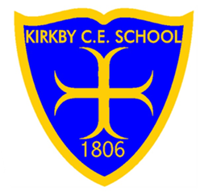
Read Write Inc. (RWI) Phonics
Progression Map
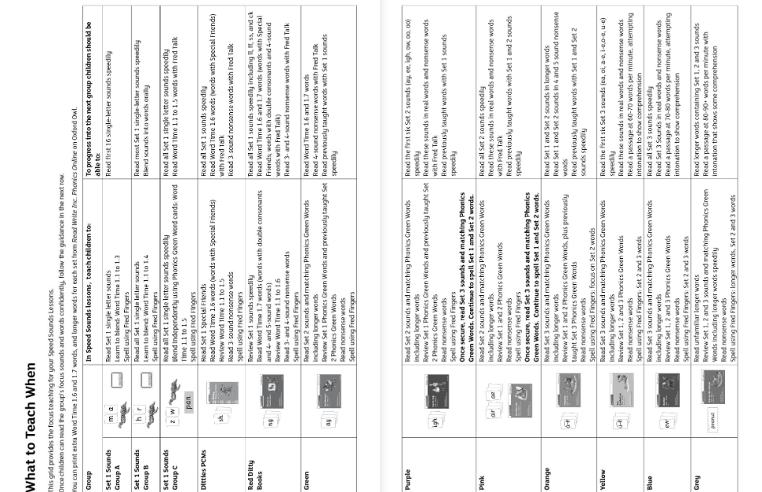
At Kirkby C of E Primary School, Read Write Inc. is where every child’s reading journey begins. Through skilled teaching, personalised support, and a love of stories, we ensure all children don’t just learn to read — they love reading too.

