Special Guardianship Welcome Pack

Special Guardianship Orders
- What is a ‘Special Guardianship Order’?
- What does a ‘Special Guardianship Order mean for the child?
- What does a ‘Special Guardianship Order mean for me?

What Support is Available to You?
- Support from Knowsley Friends and Family and SGO Team
- Coffee mornings to share experiences with other carers
- “Support plan review” will identify specific areas for support you to meet your child’s specific needs
Trauma and Attachment
- What is ‘attachment’?
- Attachment styles
- What can I do to support the child?
- What is ‘trauma’?
- Adverse Childhood Experiences (ACEs)

Useful Contacts
- Knowsley Council contacts
- Local charities and organisations

Education
- What is Pupil Premium Plus?
- What is an Educational Health and Care Plan? (EHCP)

Training
- Foster Care Training Hub.

Special Guardianship Orders

What is a Special Guardianship Order?
A Special Guardianship Order (often known as an SGO) is a legal order where the court appoints a carer – usually a relative – as the ‘Special Guardian’ of a child until they turn 18.
What does a Special Guardianship Order mean for the child?
A Special Guardianship Order gives the child security and a long-term placement. It may also help to give the child or young person links to their birth parents too if deemed appropriate.
What does a Special Guardianship Order mean for me?
If you are a child’s Special Guardian, you share parental responsibility (PR) for the child with the parents and can make nearly all the major decisions about the child without having to consult the parent. The Special Guardian has responsibility for day-to-day decisions relating to a child's care and upbringing.
Remember to keep the Special Guardianship Order in a safe place as you may need to show this as proof of PR if the child requires medical treatment or going on holiday abroad.
Parental Responsibility (PR)
Parental responsibility is where an adult is responsible for the care and well-being of a child and can make important decisions such as;
- food
- clothing
- education
- home
- medical treatment

What Support is Available to You?

Knowsley Friends and Family and SGO Team
Knowsley now has a team located within Children’s Social Care that specifically supports Friends and Family Foster Carers and Special Guardians.
Becky Gresty
Team Manager

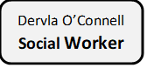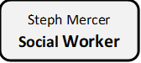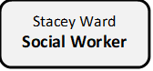
Jenny Slater Social Worker
Anne Sheerin
Social Worker

Linda Gorton
Family Support Worker
07810054153

Jodie Savage
Family Support Worker
07825145091

**Team as of July 2024**
If you feel that you require advice or support for yourself or a child that you look after, please contact our family support workers, on the numbers above who can offer advice over the phone. Depending on the support you require you may have to make a self-referral through MASH (Multi Agency Safeguarding Team)
We will be able to offer support in areas such as;
- Behavioural difficulties
- Emotional difficulties
- Family Time with birth parents
- Educational difficulties
- Signposting and referrals to specialist services

Support - Coffee Mornings/Afternoons
We would love to invite you to join us at Kirkby Fire Station Community Room, every other Wednesday morning 9.30 – 11.00am (except school holidays).
We also have a support group every other Tuesday in Prescot at Tesco’s Community Room every other Tuesday 1 – 2:30pm
At our coffee mornings/afternoons, you can meet other Special Guardians and Family and Friends Carers, receive support, advice, and chat about your experiences with others.
There are many learning opportunities with guest speakers coming along to several of the sessions.
Full address:

Webster Drive Cables Retail Park, Prescot L34 5NQ
Kirkby
L32 8SJ



Trauma and Attachment
We believe that everyone caring for a child should have knowledge about ‘trauma’ and ‘attachment’ and we want to give you a brief overview below.
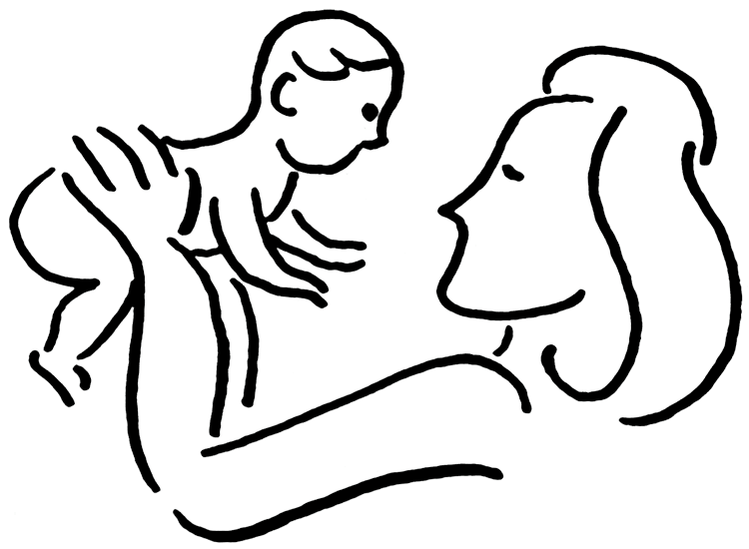
What is ‘attachment’?
Attachment refers to the relationship that develops first between the child and his primary caregiver (often the Mother).

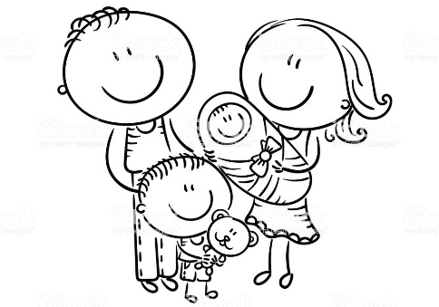
The quality of this attachment impacts on the child’s physical, emotional, psychological and cognitive development. It also shapes the child’s basic ability to trust others and how positively or negatively he/she views the world, themselves and others. It will also teach the child how to handle disappointments, opposition and stressful situations by being able to better manage their own emotions.

The quality of the first attachment the child makes, impacts all other relationships. When an infant experiences consistent care where his/her needs are met, they assume three things:
I am safe I am heard I am valuable
With this as the foundation, a child can then develop other healthy relationships.
Childs needs are met by the caregiver
Child has a sense that the world is a safe place

Attachment Styles
Secure attachment – the child may show some distress when their caregiver leaves but they are able to compose themselves knowing that their caregiver will return. Children with secure attachments feel protected by their caregivers, and they know that they can depend on them to return.
Anxious attachment – can be caused by the parent being inconsistent. Although they may be nurturing and attuned at times, they can also be insensitive, emotionally unavailable, or cold and critical at other times. Parents may also be slow or inconsistent in responding to signs of distress in their baby which cause a child to become confused and insecure since they don’t know what behaviour to expect. The child who has developed an anxious attachment toward a caregiver may act “clingy” or “whiny” toward them to try to have their needs met.
Avoidant attachment – parents tend to be emotionally unavailable or unresponsive to the child a good deal of the time. They may disregard or ignore their children’s needs, and can be especially rejecting when their child is hurt or sick. These parents may also discourage crying and encourage premature independence in their children. As a result of such parenting, the child learns to never show outwardly a desire for closeness, warmth, affection, or love. However, they will be feeling as much anxiety as other children. The child tends to seek proximity, trying to be near their attachment figure, while not directly interacting or relating to them.
Disorganised attachment – the child tends to seek closeness by freezing, distancing, avoidant and/or aggressive behaviour. The child needs to attach but is unsure if it will be safe to do so because the adult’s response could be neglectful, frightening, abusive, over-intense or appropriate and loving. The child’s responses are in effect disorganised and all over the place and this is reflected in their behaviour.

What can I do to support the child?
It is important to be aware that behaviors the child is displaying, could be linked to attachment and the child will require support to safely develop secure relationships into adulthood.
In order to do this we must ask ourselves the following questions:
- What is going on for the child right now?
- What is the child trying to communicate? (Possibly through their behaviour)
- What need are they trying to have met?
- What can I do to meet that need in a sensitive, caring and supportive way?

To help support the child you must develop your own emotional awareness by recognising your own emotions and using this to connect with the child.



What is ‘trauma’?
Trauma can be described as;
… an event, series of events, or set of circumstances that is experienced by an individual as physically or emotionally harmful or life threatening and that has lasting adverse effects on the individual’s functioning and mental, physical, social, emotional, or spiritual wellbeing.
There are different types of trauma;
Type 1 – refers to either a single event such as a car accident, single occurrence of abuse.
Type 2 – consists of multiple traumatic events over a period of time.
Type 3 – consists of repeated, often multiple forms of abuse.

Adverse Childhood Experience’s ACES
Many children and young people involved with the care system may have experienced some form of harm/trauma during their childhood which can be classified as an ‘Adverse Childhood Experience’ (ACE).
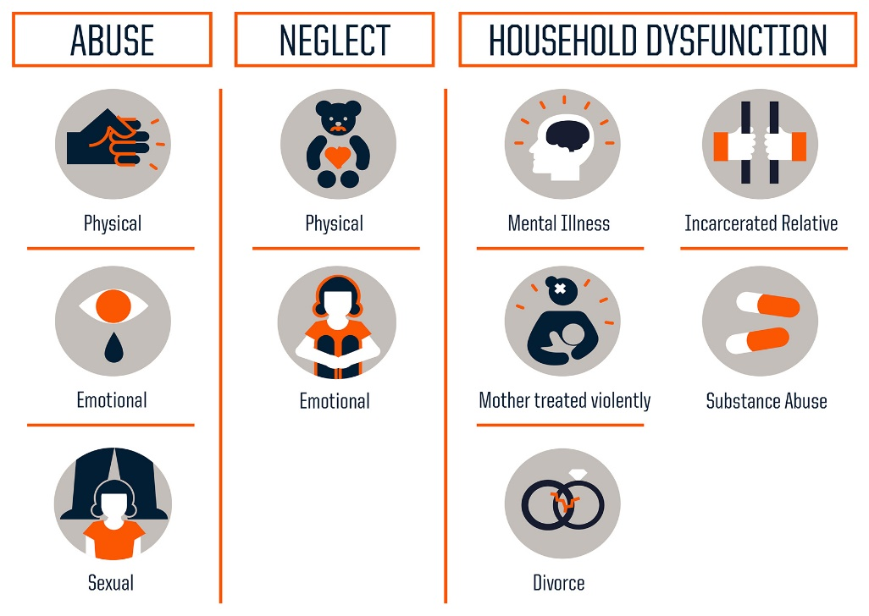
ACE’s can be categorised as;

There is a vast amount of research that has been undertaken on the above ACEs which brings together evidence that links adverse childhood experiences to the harmful impact they have on various aspects of health and social functioning.
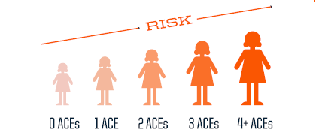
Evidence suggests that the risk of poor outcomes increase with the number of ACEs suffered;

Making negative judgements about themselves, other people or their future. | The belief that ‘I believe the worse’, making them feel like they want to hide away. | Problems with boundaries – relationships do not follow patterns.
Struggling to describe their feelings/emotions. | Struggle to make safe decisions because stress shuts down their thinking capacity. | Anger, upset about the trauma, causing them to lash out at people trying to get help.
Self-harm, drug and alcohol use | Physical and verbal aggression, behaving in ways that invoke social sanctions and exclusion. | Struggles with decision making.
Under or over responding to perceived threats, particularly in relationships. | Sleep and appetite changes. | Avoidance of triggers, staying away from certain environments, people or reminders associated with the trauma.

Below are some of the impacts of trauma/ACEs on physical, psychological and social functioning and how they might be experienced by young people:
We often tend to get caught up focusing on the child’s behaviour rather than the need. Which often leads to blame, shame, and escalation in behaviours. Turn your focus back to asking the questions in the attachment section which focus on what the child is trying to communicate to us.

Useful Contacts

Knowsley council information and contacts
Special Guardianship Order Payments - How do Knowsley assess and review financial arrangements?
Special Guardianship finances are assessed via an on-line financial assessment tool, this can be completed at home or with the help of one of the council’s one-stop-shops. Once the potential guardian has been assessed by Knowsley’s Revenues and Benefits team, an application is made to the courts to make the arrangement legal.
Special Guardianship finances are reviewed annually and also reviewed if there is a significant change in finances. Since 2012, Knowsley council pay Special Guardians the same rate as foster carers, the Special Guardianship payment is made up of any Child Benefit and Child Tax credit awarded and topped up by a payment from the Council, to equal the foster care payment.
You can contact Jake Hegarty - finance team on 07385 945038 who can help with your enquiry.

Who do I contact if I have concerns regarding the welfare of a child in my care or if I require support to continue caring for them?

Knowsley MASH team 0151 443 2600 should be contacted if you need to raise concerns about the safety and welfare of children, and if you feel that you require professional support in looking after the child or young person.

Emergency Duty Team (EDT) 0151 443 2600 acts as the ‘first point of contact’ for Children’s or Adults Social Care out of office hours. EDT will only respond to Emergencies that cannot wait until the next working day. This is usually circumstances where there are immediate concerns regarding the welfare or

Safety of children or adults or if there is a risk of family breakdown and the Children are being placed in ‘care’.

Who do I contact if I need support regarding contact with parents/ behavioural, emotional or educational issues?
Please contact the Friends and Family and SGO Team, numbers below, to speak to a family support worker who will advise on what steps you need to take.
Jodie Savage 07825 145091
Linda Gorton 07810 054153

Local charities and organisations
Please find information about Local charities and organisations that offer a wide range of support services in Knowsley that you and your child can access;
Please see the Knowsley information service website for activities, support groups and more, around Knowsley: www.knowsleyinfo.co.uk

Kinship UK
Website: kinship.org.uk
The leading kinship care charity in England and Wales. We’re here for kinship carers – friends or family who step up to raise a child when their parents aren’t able to.

ADDvanced Solutions Community Network
Phone: 0151 486 1788
Website: www.addvancedsolutions.co.uk
The network encourages, equips and empowers children, young people and their families living with neurodevelopmental conditions, learning difficulties and associated mental health needs, through engaging activities to help you and your family to better recognise, understand and meet your individual needs, enabling you to manage the day to day challenges.

The Knowsley Parent Carers Voice
Phone: 0151 549 1412
Email:parentcarersvoice@knowsleycarers.co.uk
A group of parents and carers of children with special education needs and disabilities from Knowsley who meet up at different centre’s around the borough.

Stars Liverpool
Phone: 07914794492 or 07901557781
Email: littlestars.knowsley@gmail.com
Parent support group for children aged 5-14 years with additional needs and their families. Support through coffee mornings, stay and play sessions and other activities.

Short Breaks MYA Choices Knowsley – Kirkby/Halewood (Ages 4-11yrs)
Phone: 0151 443 5085
Email: shortbreaks@Knowsley.gov.uk
Sessio​ns are open to children and young people (as per ages in title) with Additional Needs who are Knowsley residents. The sessions are structured and based around the individual needs of each child and provide a variety of activities.

Education

What is Pupil Premium Plus?
Children who were previously looked after by a local authority in England and Wales and who are now subject to a special guardianship order, are eligible to attract annual pupil premium funding.
This is additional funding, of £2,300 per pupil, provided to schools to help them improve the education of previously looked-after children. They should also benefit from the support of the school’s designated teacher for previously looked-after children.
Special Guardians need to ensure their child’s status is recorded on the school’s census; this is voluntary, but schools will only receive the funding if the child is listed on their census.
Please check with your child’s school that the child is recorded as being a ‘previously looked after child’ and is subject to a ‘Special Guardianship Order’.
What is an Educational Health and Care Plan (EHCP)?
EHC plans are for children and young people whose special educational needs require more help than would normally be provided in a mainstream education setting (a college, school, and nursery). If you think your child needs an EHC plan speak to the child’s school or you’re Local Authority? If the decision is to carry out an assessment you may be asked for:
- Reports from your child’s school, nursery or childminder
- Doctors’ assessments of your child
- A letter from you about your child’s needs

Priority in schools admissions criteria
Children who have left care under a Special Guardianship Order must be given priority in schools admissions criteria. Make sure you mention it in your application.

Financial Support

In general, financial support is payable in the following circumstances:
- Where the Local Authority considers such financial support necessary to ensure the Special Guardian can look after the child;
- Where the Local Authority considers that the child needs special care which requires a greater expenditure of resources than would otherwise be the case because of his or her illness, disability, emotional or behavioural difficulties or the consequences of past abuse or neglect. This would take into account the benefit entitlements to the Special Guardian. For example child disability tax credits and or DLA. However,
the needs of the child when assessed will take the usage of the benefits before additional resources are requested;
- Any discretionary financial support will only be paid to meet the individual needs of the child. This decision will be made via the Permanence Panel.
Financial support is subject to reviews being undertaken. These reviews will be the responsibility of the Special Guardian and the local authority. If any changes occur with the Special Guardian they must inform the Local Authority to prevent any overpayments taking place.

Special Guardians will receive a support plan which will include the initial financial arrangement information, this assessment and support plan is written in the final court ordered papers and the payment becomes a legal arrangement.

Adoption and Special Guardianship Support Fund
The adoption support fund (ASGSF) provides funds to local authorities (LAs) to pay for essential therapeutic services for eligible special guardianship order families.
Funding Eligibility
The ASGSF is available for children up to and including the age of 21, or 25 with an education, health and care (EHC) plan, who:
- were in care immediately before a SGO was made.
- left care under a special guardianship order which subsequently was changed to an adoption order, or vice versa.
- Left care under a child arrangement order (CAO) to enable the assessment of a potential special guardian, while the CAO is in force. They remain eligible if a SGO is subsequently made.
Funding allocations
Until the end of the financial year 2024 to 2025 the ASGSF will have 2 fair access limits:
- £2,500 per child per year for specialist assessment/£5,000 per child per year for therapy

How families access ASGSF support
The LA that places a child with a family is responsible for assessing that family’s support needs for 3 years after the order is made. After 3 years, the responsibility lies with the LA where the family lives, if they have moved. Families apply to the relevant LA which will assess their needs.
The LA will then;
- assess the family and consider if therapeutic support is needed.
- decide on the type required, if it is eligible for funding, and apply direct to ASGSF.
- purchase the support from their own list of approved suppliers when the ASGSF approves funding.

Training

Online training portal
You can currently access training through the Foster Care Hub.

Here is a step by step guide:

1. Please visit fostering.knowsley.gov.uk (please note www. does not work as the hub is a microsite)
2. Click Create Account at the top right of the screen.
3. Enter your details. Make sure the email address is spelled correctly as a confirmation
email will be sent here.
4. The security code is: KFoster6766
5. Enter a memorable password. The password must contain at least one letter, one number and one non letter or number character
(punctuation mark). Make sure you can remember this.
6. Click Register
7. You will receive an email from the fostering team which will ask you to click on a link to confirm your account.
8. You must click on this link and you can then log in using your email address and password. Sometimes the email goes into people’s junk box so always check there too.

