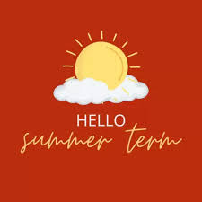
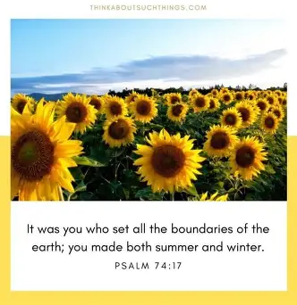
Class Novel/Book
William Kamkwamba – The boy who harnessed the wind.

PSHE
Relationships
The class will focus on relationships, learning about what makes healthy and respectful relationships with friends, family and others. They will explore communication skills, managing conflict, and understanding feelings, as well as the importance of respect, boundaries and consent.
Spanish
Children will learn vocabulary and phrases linked to healthy lifestyles in Spanish. They will talk about food, exercise and daily habits, building confidence in speaking, listening, reading and writing. Children will practise forming simple sentences to express preferences and describe healthy choices.

PE
Outdoor – Orienteering
Children will take part in orienteering activities, using maps and clues to navigate a course. Teamwork, problem-solving and decision-making skills will be developed.
Indoor – Health Related Fitness
Children will develop their fitness through a range of activities focused on strength, stamina, flexibility and coordination.

Music
Dancin’ in The Street
All the learning in this unit is focused around one song: Dancing in The Street by Martha and The Vandellas.
Computing
This half term, children will learn how to use word processing software to create and present documents effectively. They will develop typing and formatting skills, learn to edit and develop their work. Children will also learn how to insert images and organise text for different purposes. By the end of this unit, children will understand how to produce well-structured, polished documents independently.

Geography
Magnificent Mountains

This half term, pupils will explore significant mountains around the world, learning how they are formed and where they are located. They will develop map skills, including using atlases and digital mapping, and investigate the physical features of mountain environments. Children will also consider how mountains affect human activity, including settlement, tourism, and climate.
R.E
Exploring the lives of significant women in the Old Testament
This half term, children will learn about significant women in the Bible, exploring their stories and the impact they had. They will develop their understanding by asking and answering questions about figures such as Jochebed, identifying leadership qualities in Deborah, and reflecting on themes like loyalty through Ruth’s story. They will also learn about Esther and understand why her story is celebrated during the Festival of Purim.

Topic Map: Year 5 & 6
Term: Summer 1

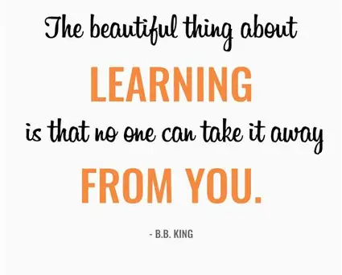
Science
Life Cycles
This half term, our Year 5 and 6 scientists will be exploring the fascinating world of Life Cycles. We will be investigating the diverse ways in which different species grow and reproduce, comparing the life cycles of mammals, birds, amphibians, and insects. Pupils will learn to identify the distinct stages of development—from the complete metamorphosis of a butterfly to the growth of a bird within an egg. Through observation and research, they will gain a deep appreciation for the variety of life on our planet and the common threads that connect all living things.

Mathematics
Year 5
Children will develop their understanding of number and calculation. They will practise mental strategies and work with addition and subtraction of large numbers, including multi-step problems. We begin by exploring Area and Perimeter, where pupils will move beyond simple counting to calculate the area of compound shapes and estimate the volume of 3D objects. In our Statistics unit, the children will learn to interpret and construct complex line graphs and timetables, developing their ability to solve "comparison, sum and difference" problems using information presented in a grid.
Year 6
In the lead-up to their final assessments and secondary transition, Year 6 will focus on consolidating and extending their mastery of key mathematical concepts. We will begin with a rigorous review of Number and place value, ensuring fluency in multi-step calculations involving all four operations. Our work on Area, Perimeter, and Volume will see the children move toward algebraic thinking, as they use formulae to calculate the area of parallelograms and triangles, and the volume of cubes and cuboids. In Statistics, pupils will tackle more sophisticated data sets, learning to interpret and construct pie charts. To conclude the half term, our Shape unit will challenge pupils to draw and classify 2D and 3D shapes based on complex properties, as well as find unknown angles in any polygon, at a point, or on a straight line.
English
Writing- Information guide and a newspaper report
Our young authors will be diving deep into the world of non-fiction, using our captivating class book as a springboard for their writing. They will learn to master organisational features such as subheadings, technical vocabulary, and factual diagrams. Following this, we will shift our focus to the fast-paced world of journalism. The children will learn to "report the facts" by crafting a formal Newspaper Report.

SPAG
Over the course of this half term, we will cover the following SPaG objectives:
- Cohesive Devices: Using adverbials of time (later), place (nearby).
- Parenthesis: Using brackets, dashes, or commas to add extra information.
- • Advanced Punctuation (Year 6): * Colons and Semi-colons and hyphens to avoid ambiguity (e.g., man-eating shark vs. man eating shark).
- Bullet Points: Consistent punctuation when listing information.
Reading
Over the course of this half term, we will cover the following Reading objectives:
- Increase familiarity with a wide range of books, including myths, legends, traditional stories, modern fiction, fiction from other cultures and literary heritage texts.
- Identify and discuss themes and conventions across a wide range of writing.
- Draw inferences about characters’ feelings, thoughts and motives from their actions, and justify inferences with evidence from the text.

